**Course-End Project**

**Automating Deployment to Azure Web App with Application Containers**

Steps to be followed:

1. Create Terraform scripts to automate Azure infrastructure automatically
2. Configure Azure Web app for Containers with high availability configuration
3. Configure Jenkins to automate CI CD workflow

**Step 1:** **Create Terraform scripts to automate Azure infrastructure automatically**

* 1. Open the terminal in the DevOps lab

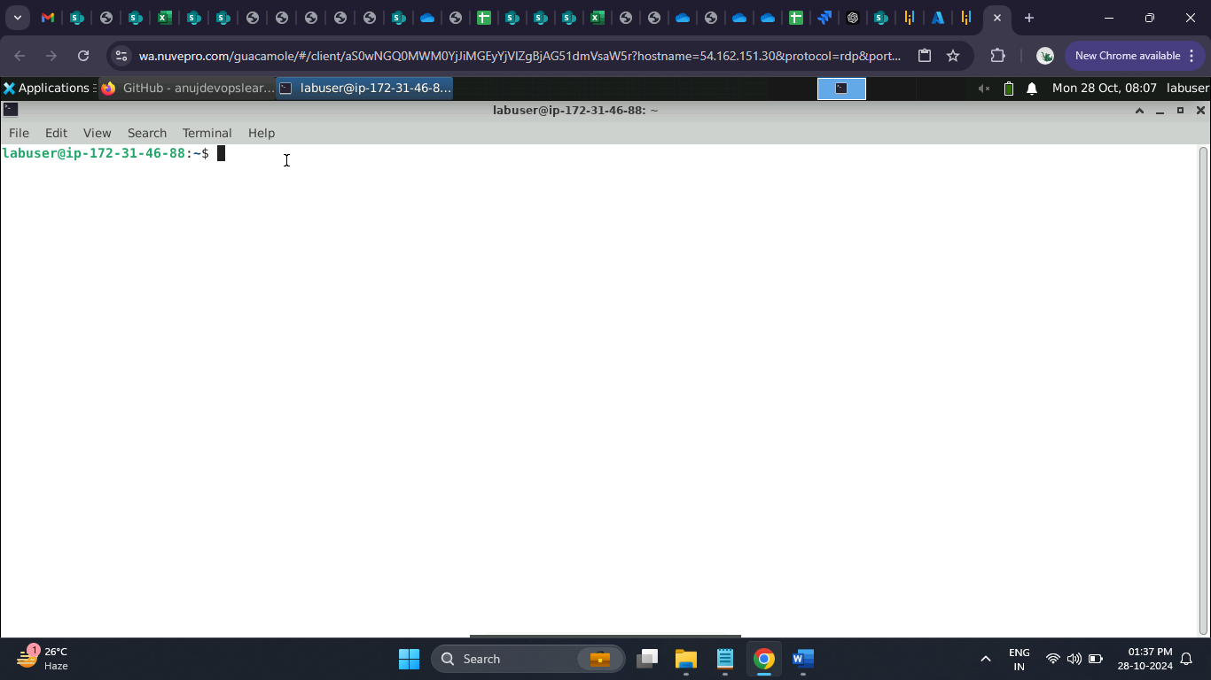

* 1. Run the below command to make a directory

**mkdir azure**

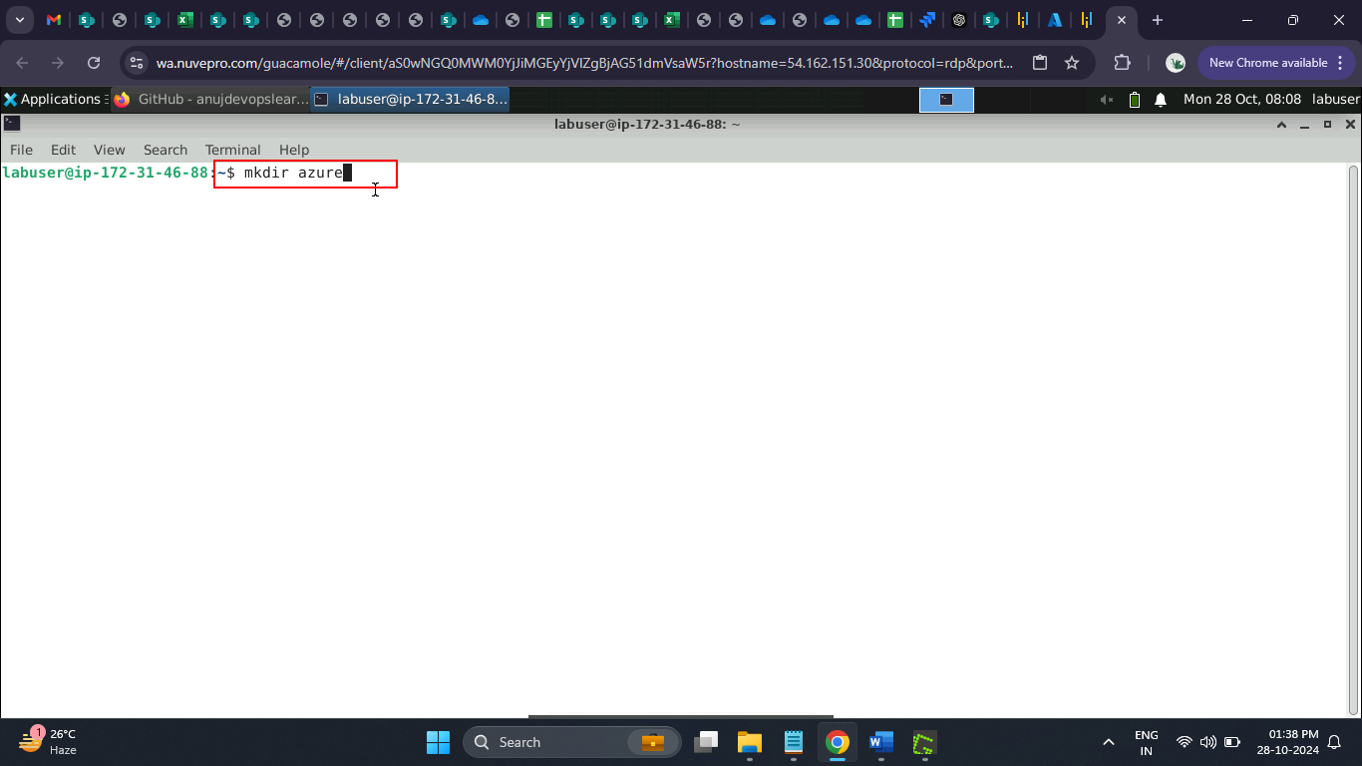

* 1. Run the below command to enter the created directory

**cd azure**

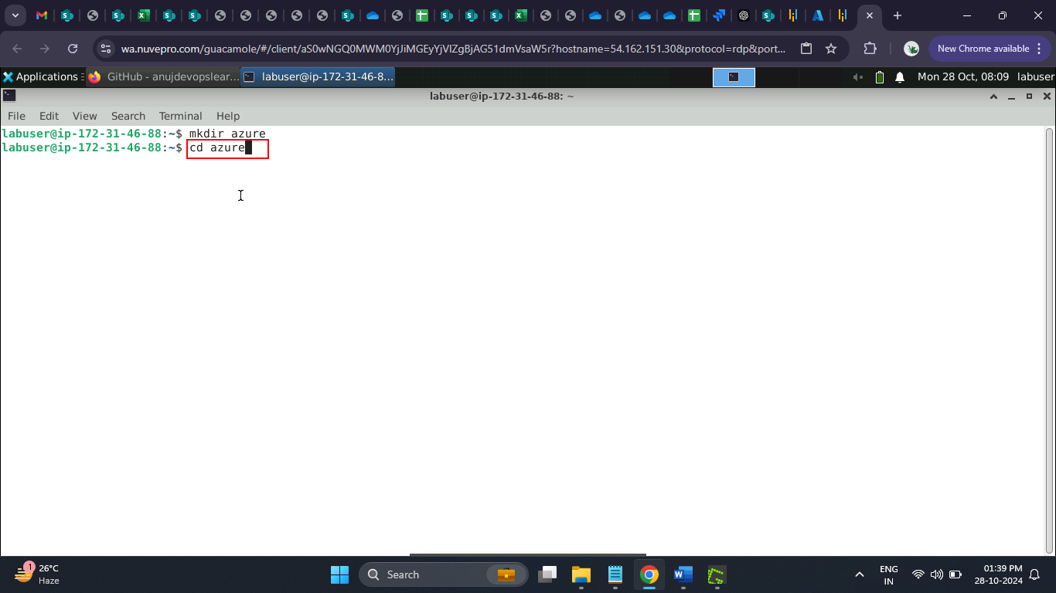

The Azure directory opened successfully.

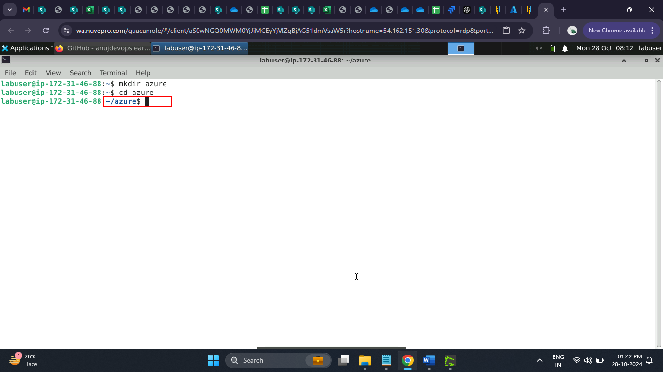

* 1. Navigate to the Azure portal to copy the resource group name and the subscription id

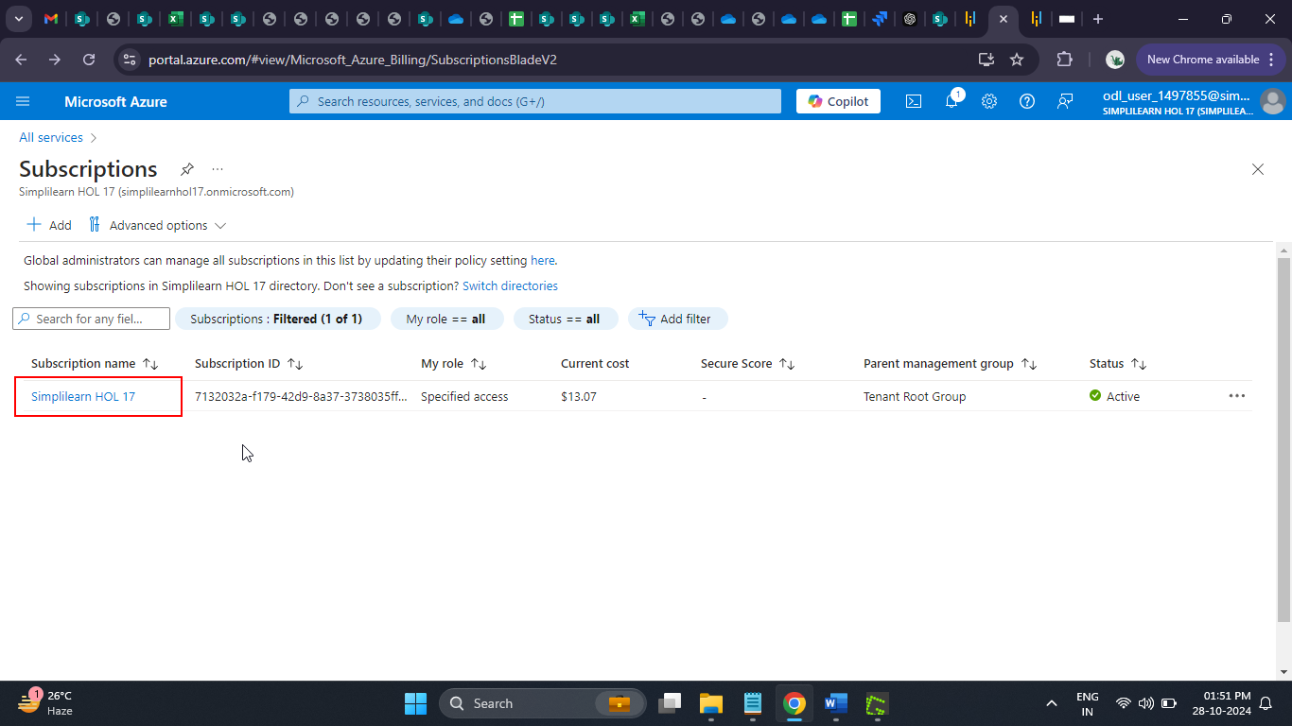

* 1. Copy the **Subscription ID**

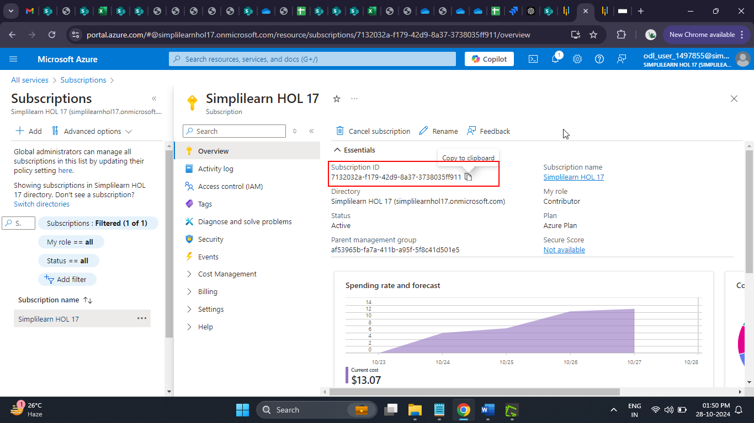

* 1. Navigate to the **Resource groups**

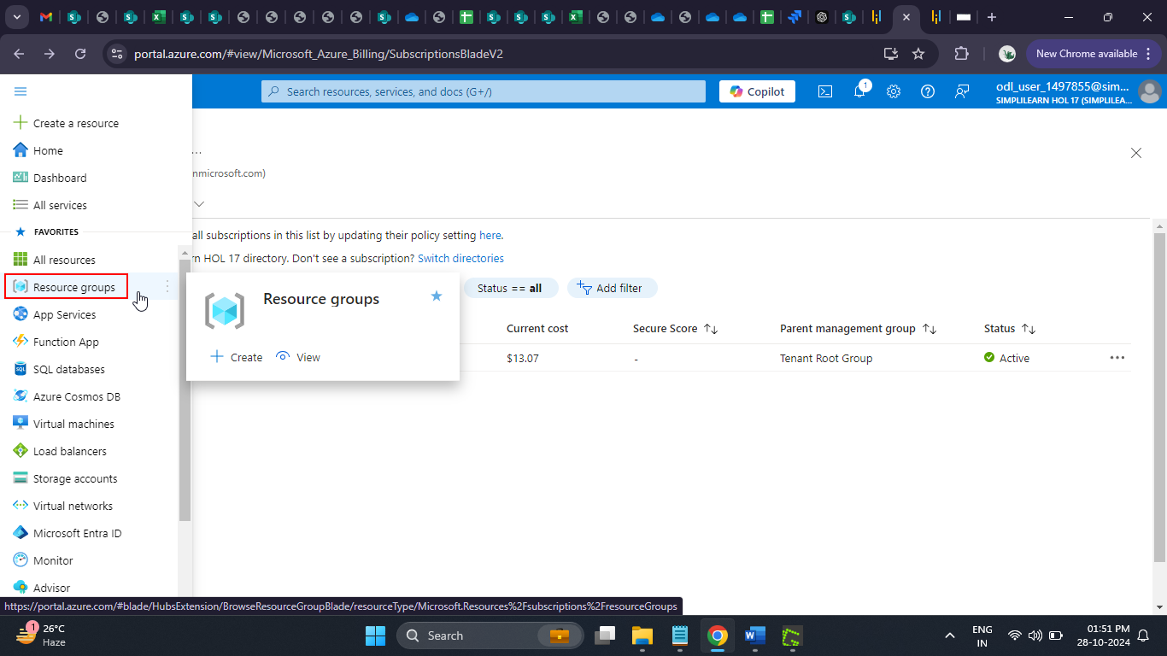

* 1. Copy the **Resource group** name

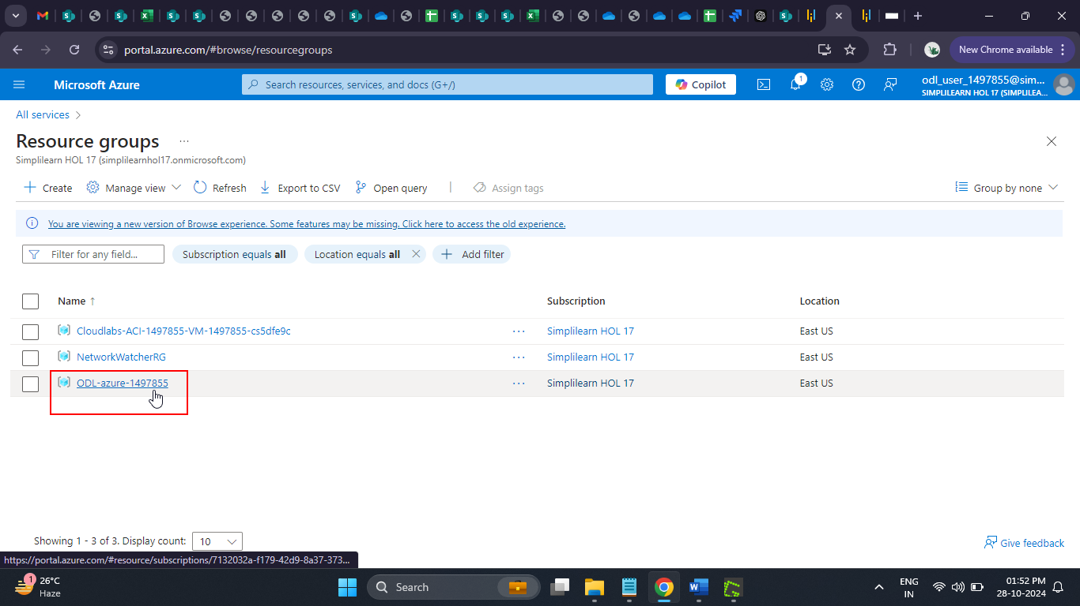

* 1. Navigate back to the terminal



* 1. Enter the code below to Create the **backend.tf** file with the specified content

**cat > backend.tf << EOL**

**terraform {**

**required_providers {**

**azurerm = {**

**source = "hashicorp/azurerm"**

**version = "4.4.0"**

**}**

**}**

**}**

**provider "azurerm" {**

**features {}**

**resource_provider_registrations = "none"**

**subscription_id = "7132032a-f179-42d9-8a37-3738035ff911"**

**}**

**EOL**

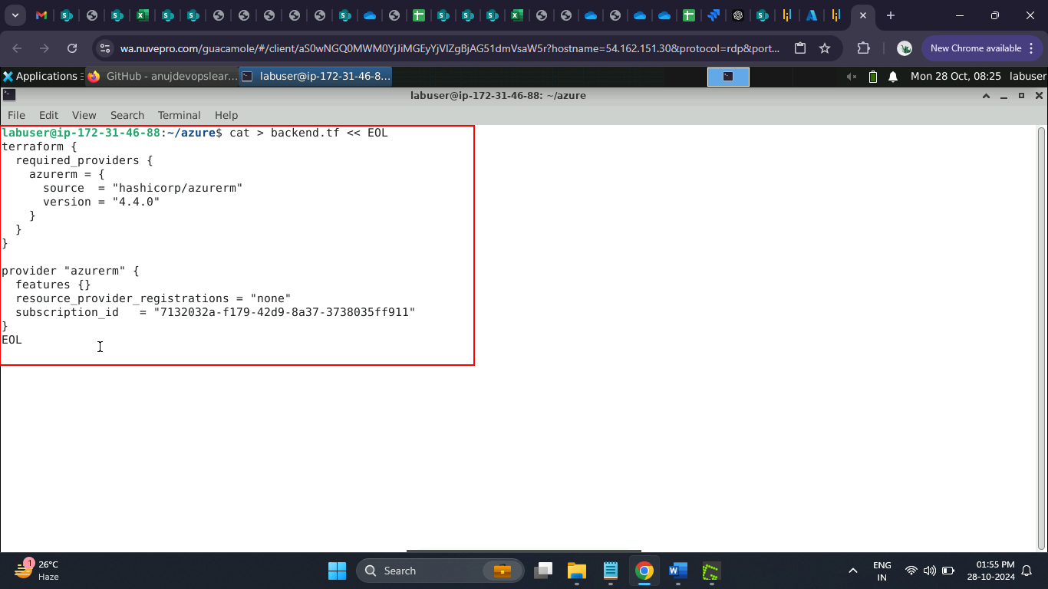

* 1. Enter the code below to Create the **variables.tf** file with the specified content

**cat > variables.tf << EOL**

**variable "project_name" {**

**type = string**

**description = "Project name"**

**default = "azurewebapp"**

**validation {**

**condition = can(regex("^[a-zA-Z0-9]*\$", var.project_name))**

**error_message = "The project_name must be alphanumeric."**

**}**

**}**

**variable "image_name" {**

**type = string**

**description = "Image name"**

**default = "backendapp"**

**validation {**

**condition = can(regex("^[a-zA-Z0-9]*\$", var.image_name))**

**error_message = "The image_name must be alphanumeric."**

**}**

**}**

**variable "resource_group_location" {**

**type = string**

**description = "Location for all resources."**

**default = "eastus2"**

**}**

**variable "resource_group_name_prefix" {**

**type = string**

**description = "Prefix of the resource group name that's combined with a random ID so name is unique in your Azure subscription."**

**default = "ODL-azure-1497855"**

**}**

**variable "subscription_id" {**

**type = string**

**description = "Subscription ID for Logged in Azure Account"**

**default = "7132032a-f179-42d9-8a37-3738035ff911"**

**}**

**EOL**

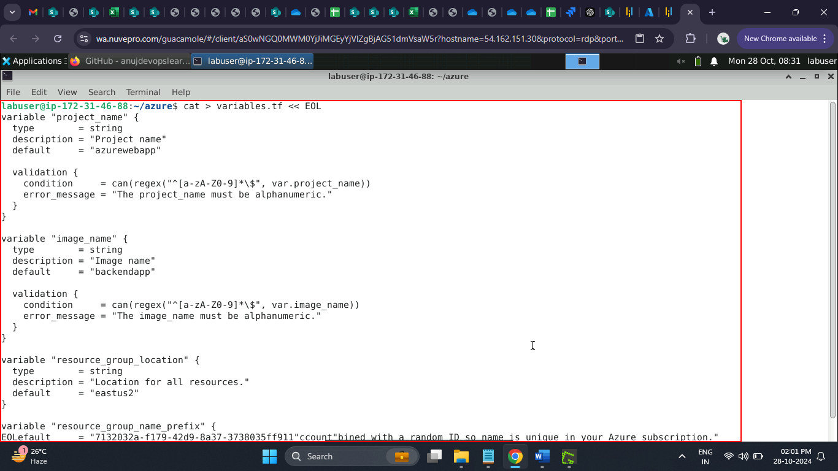

* 1. Enter the code below to Create the **acr.tf** file with the specified content

**cat > acr.tf << EOL**

**resource "azurerm_container_registry" "acr" {**

**name = "\${var.project_name}azurewebappregistry"**

**resource_group_name = "ODL-azure-1497855"**

**location = "\${var.resource_group_location}"**

**sku = "Standard"**

**admin_enabled = true**

**}**

**EOL**

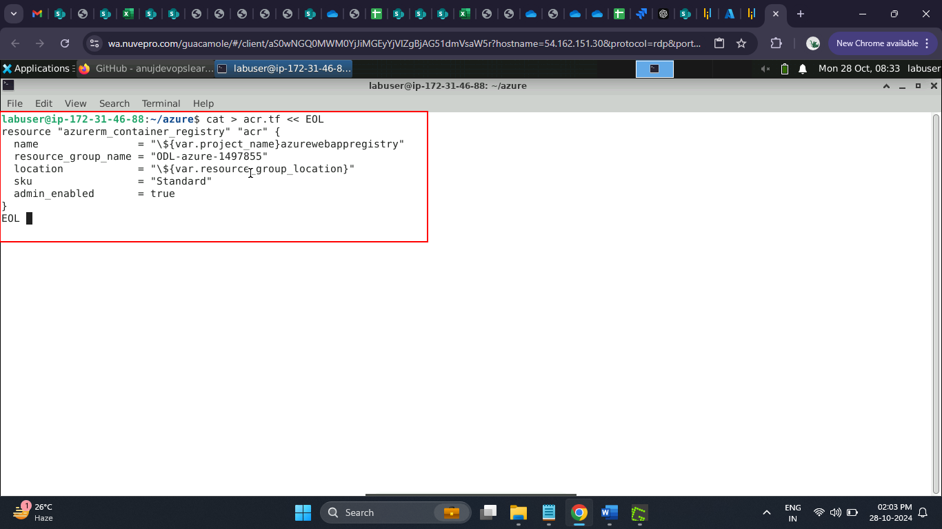

* 1. Enter the code below to Create the **app_service.tf** file with the specified content

**cat > app_service.tf << EOL**

**resource "azurerm_service_plan" "backend" {**

**name = "\${var.project_name}-appserviceplan"**

**resource_group_name = "ODL-azure-1497855"**

**location = "\${var.resource_group_location}"**

**os_type = "Linux"**

**sku_name = "P1v2"**

**}**

**resource "azurerm_linux_web_app" "backend" {**

**name = "\${var.project_name}-webapplication"**

**resource_group_name = "ODL-azure-1497855"**

**location = "\${var.resource_group_location}"**

**service_plan_id = azurerm_service_plan.backend.id**

**site_config {**

**always_on = "true"**

**application_stack {**

**docker_image_name = "\${azurerm_container_registry.acr.login_server}/\${var.image_name}:latest"**

**docker_registry_url = "https://\${azurerm_container_registry.acr.login_server}"**

**docker_registry_username = azurerm_container_registry.acr.admin_username**

**docker_registry_password = azurerm_container_registry.acr.admin_password**

**}**

**}**

**}**

**EOL**

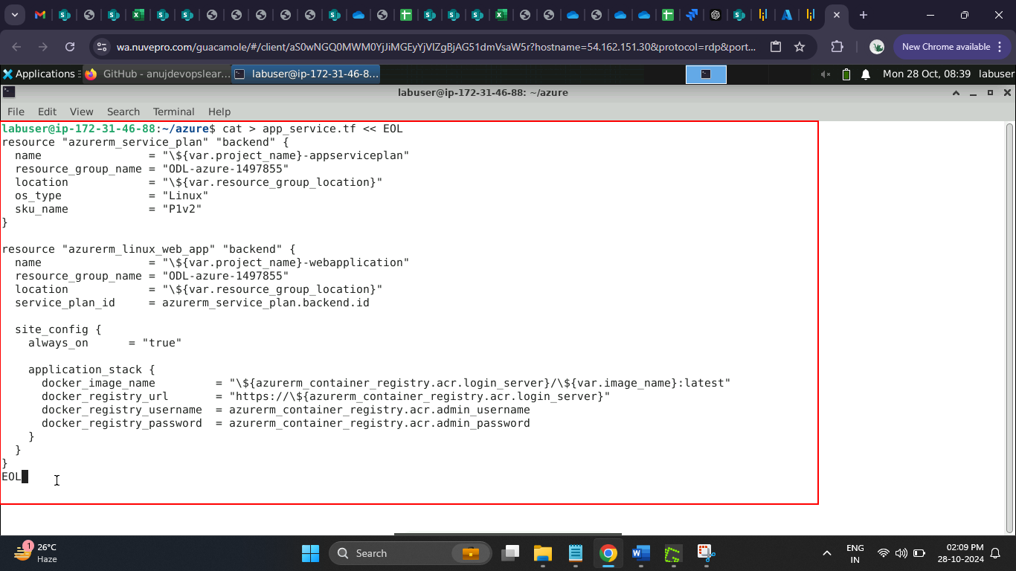

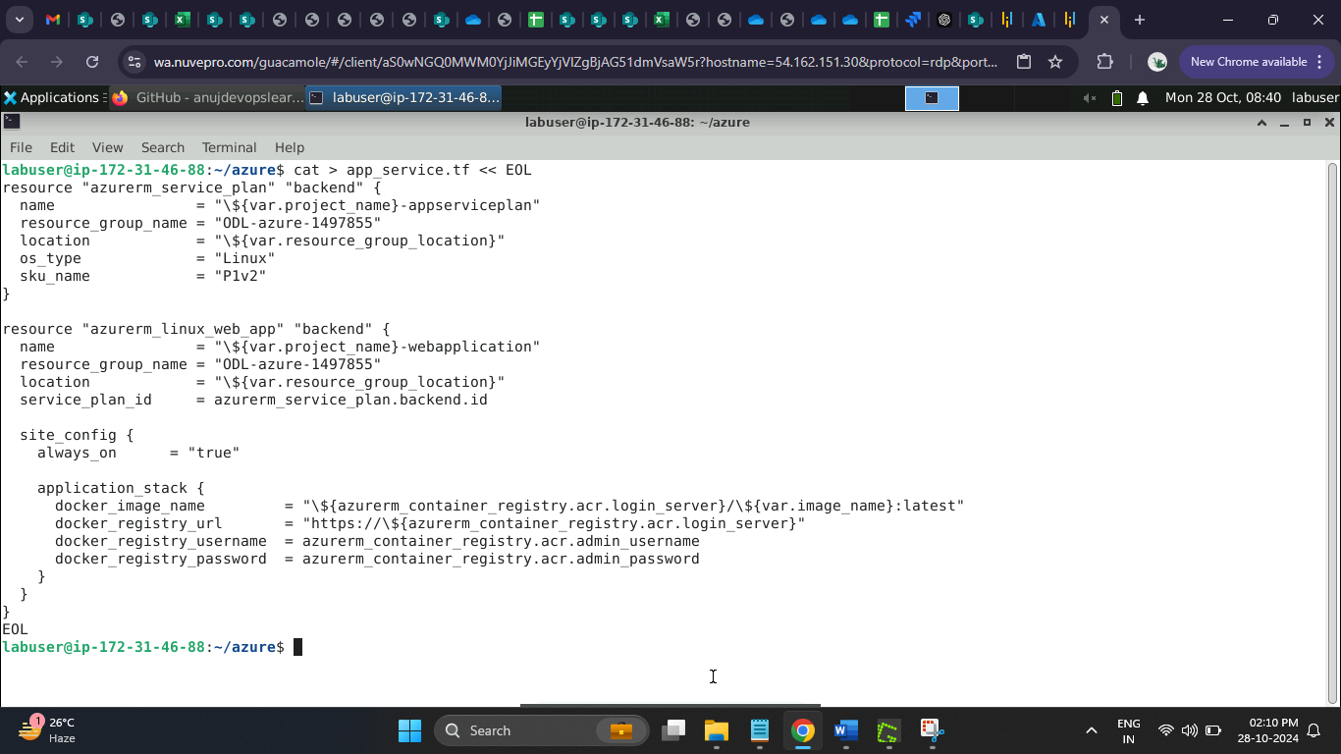

* 1. Run the command below to configure the Azure CLI to authenticate with your Azure account, allowing Terraform scripts to be applied

**curl -sL https://aka.ms/InstallAzureCLIDeb | sudo bash**

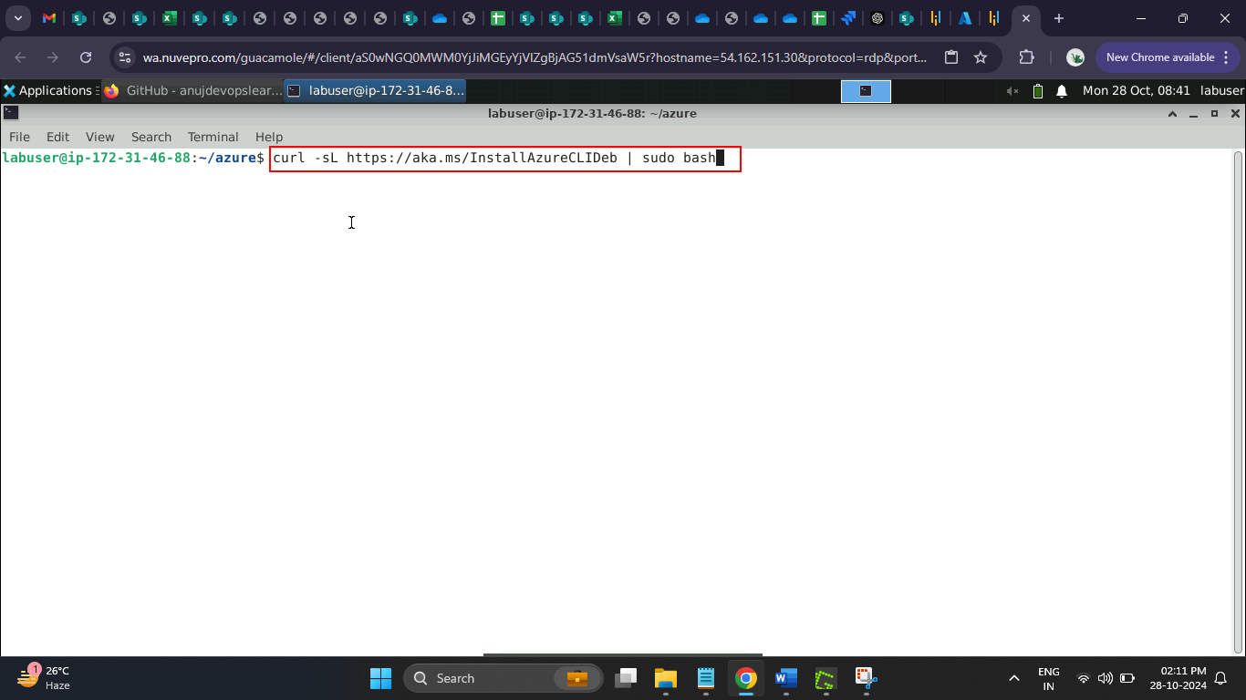

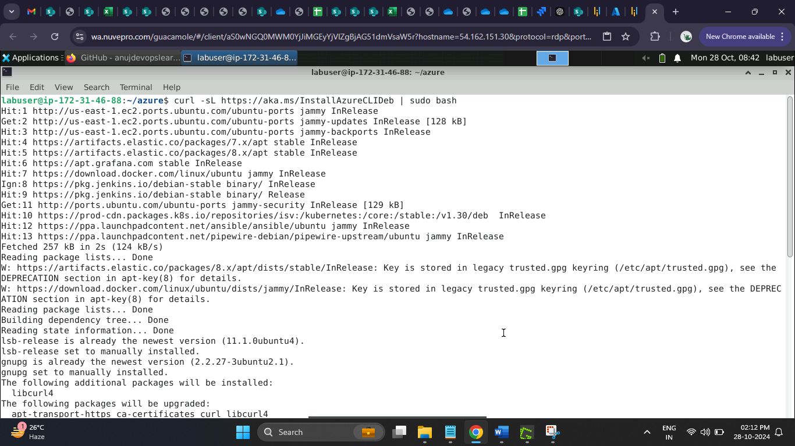

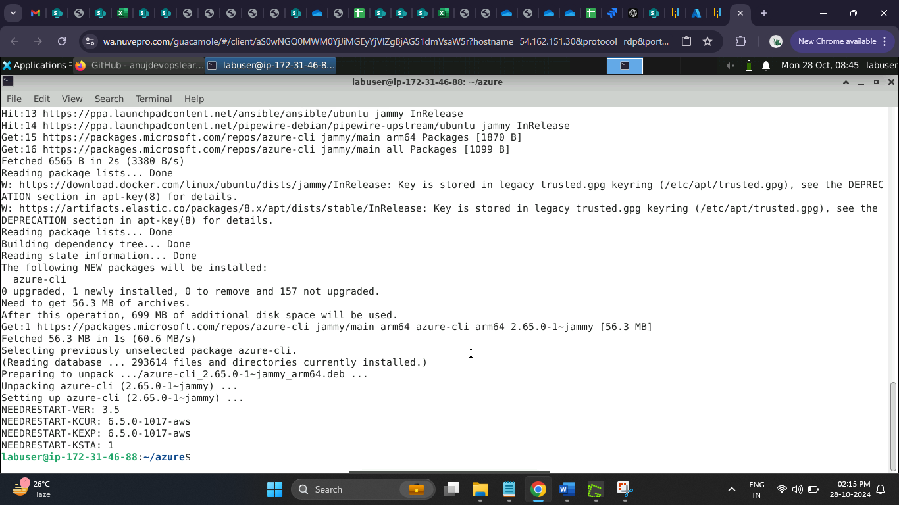

* 1. Run the command below to proceed with authentication to Azure Cloud

**az login**

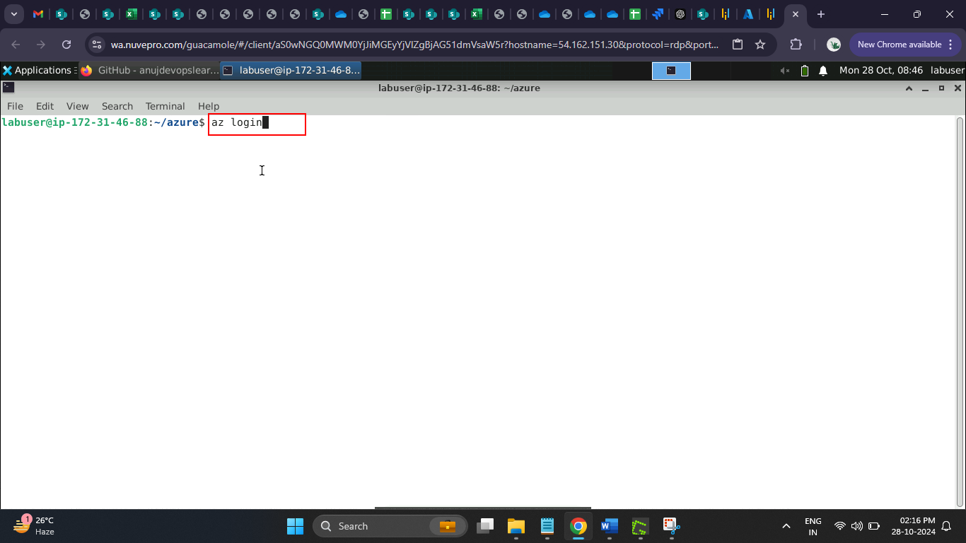

The Azure login page opens in the browser.

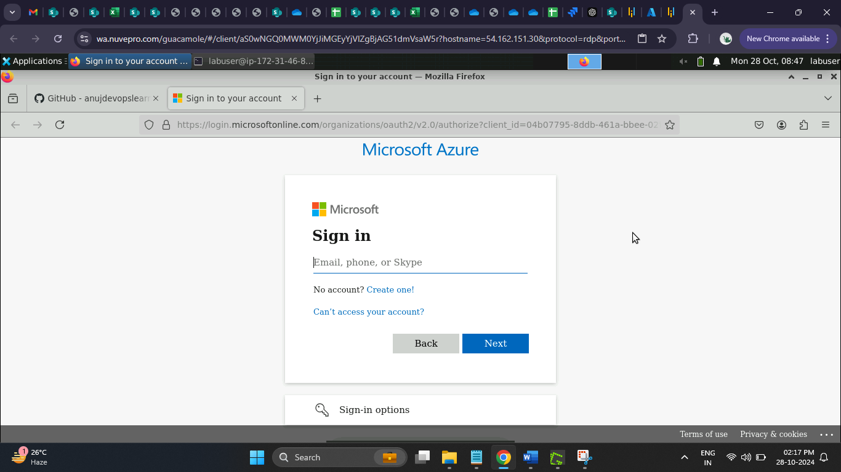

* 1. Navigate to the Azure lab and copy the login credentials

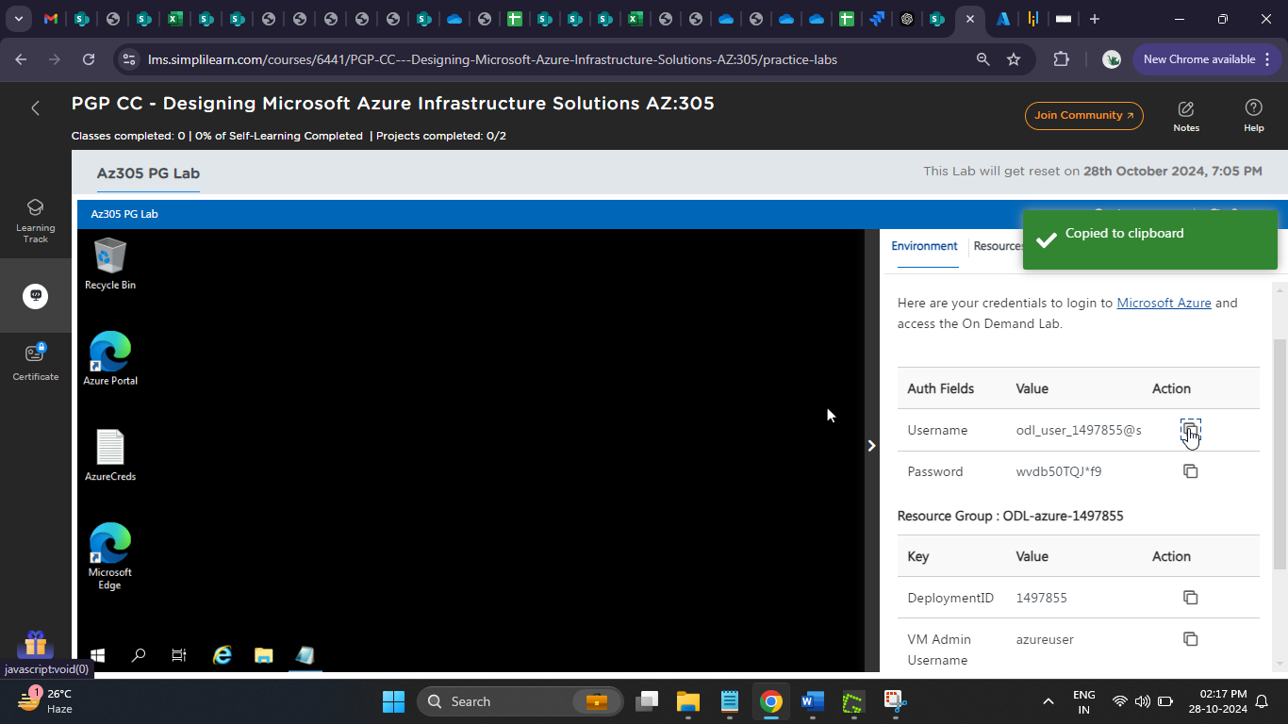

* 1. Paste the **Username** in the browser and click on the **Next** button

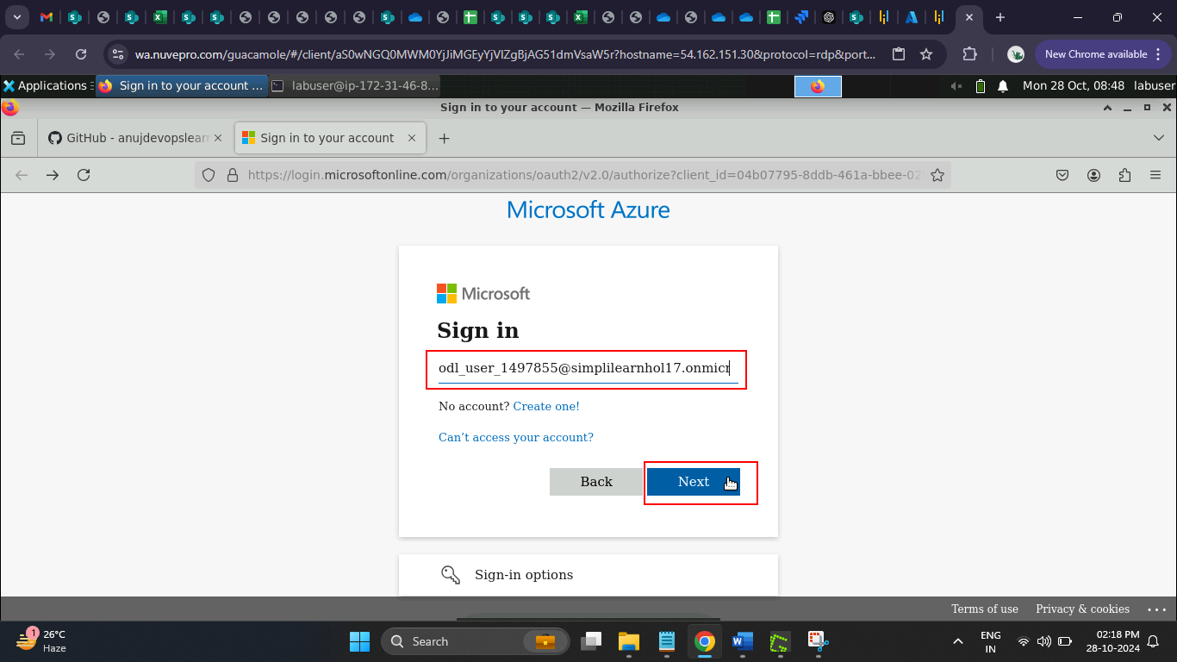

* 1. Copy the password from the Azure lab

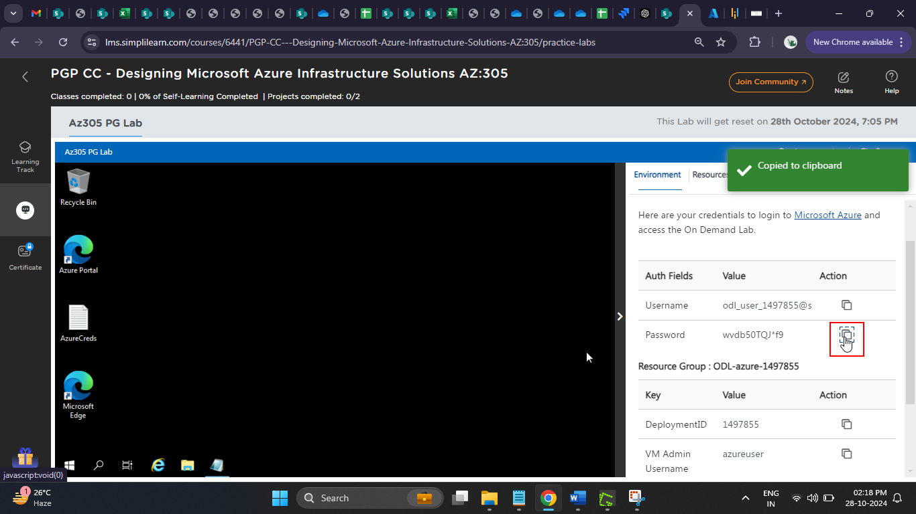

* 1. Paste the **Password** in the browser and click on the **Sign in** button

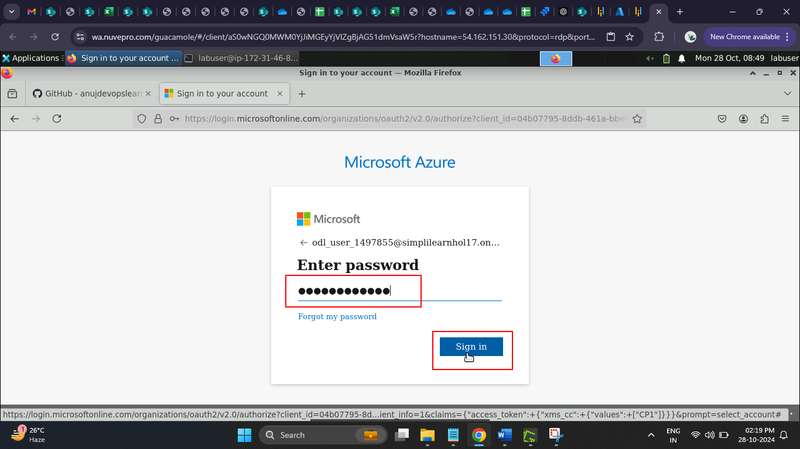

You will be successfully logged into the Azure account.

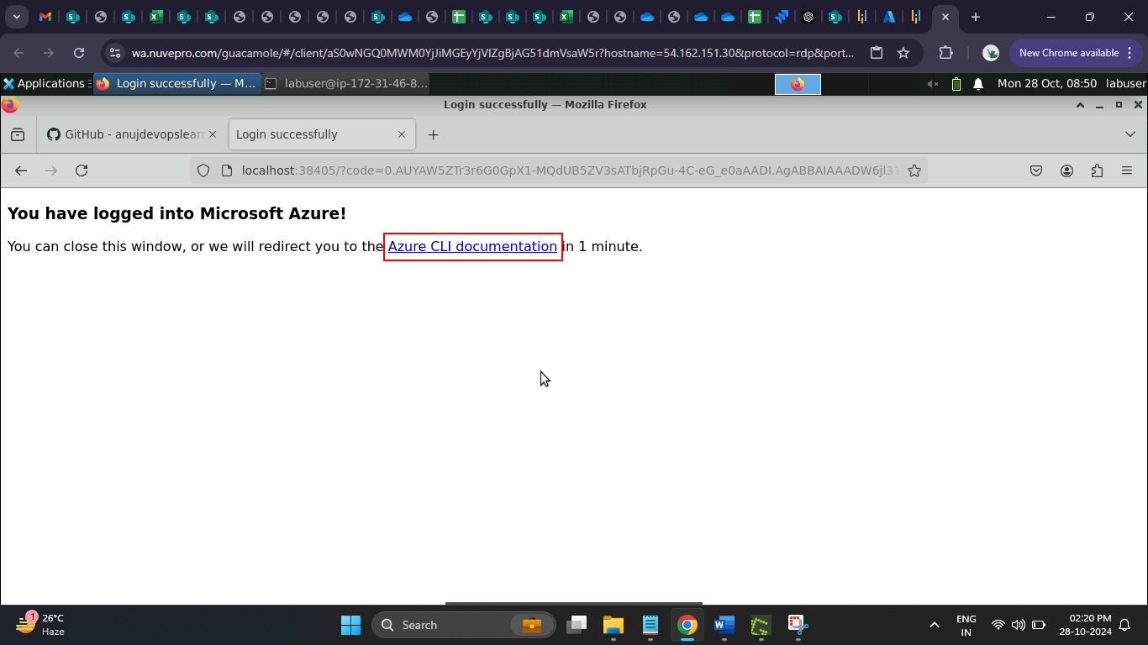

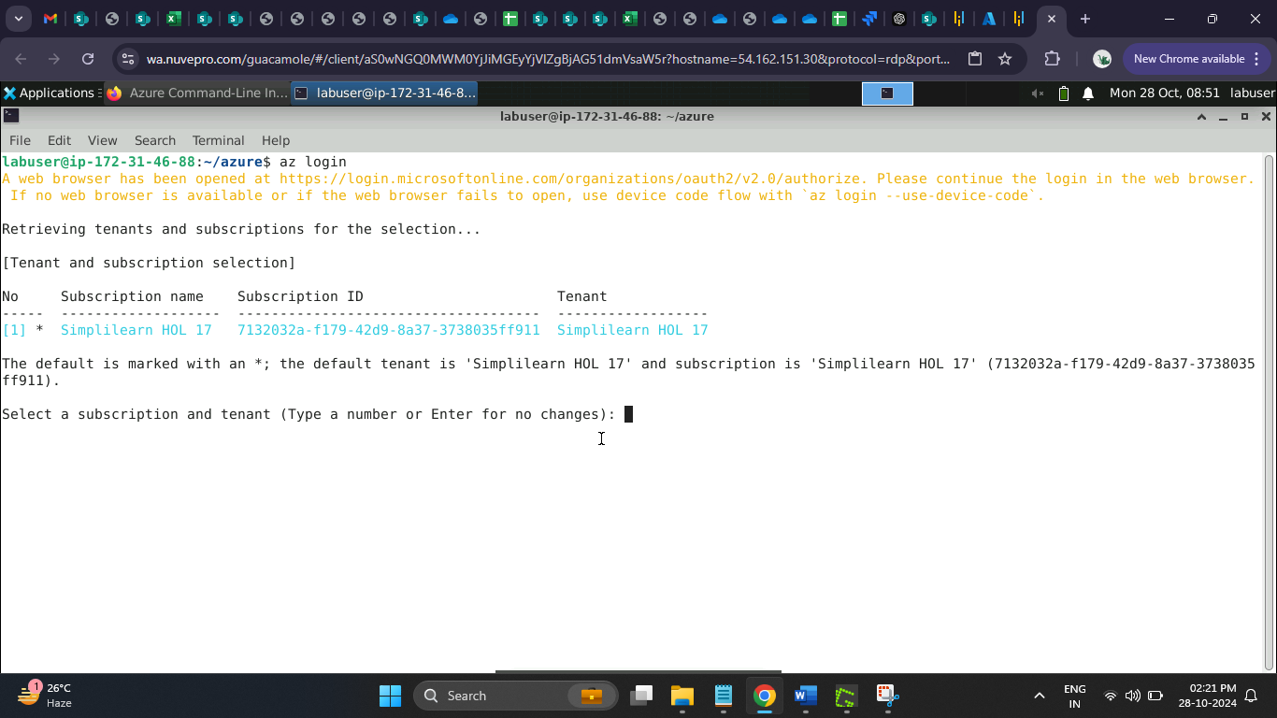

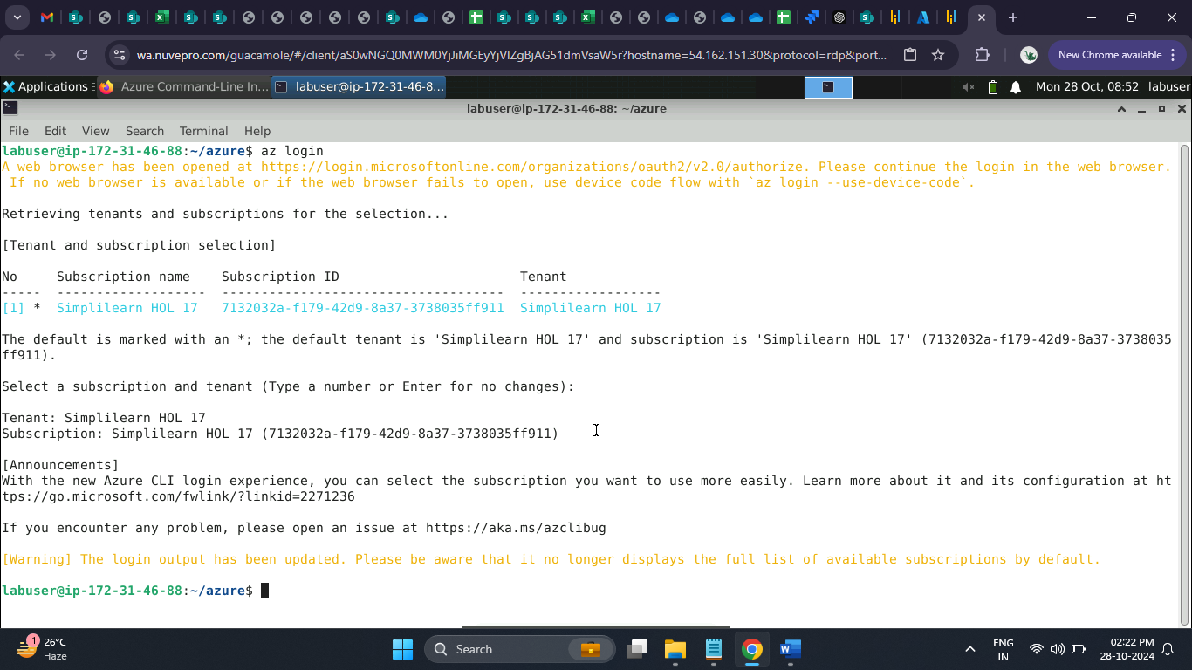

* 1. Execute the below command to get the Azure account list

**az account list**

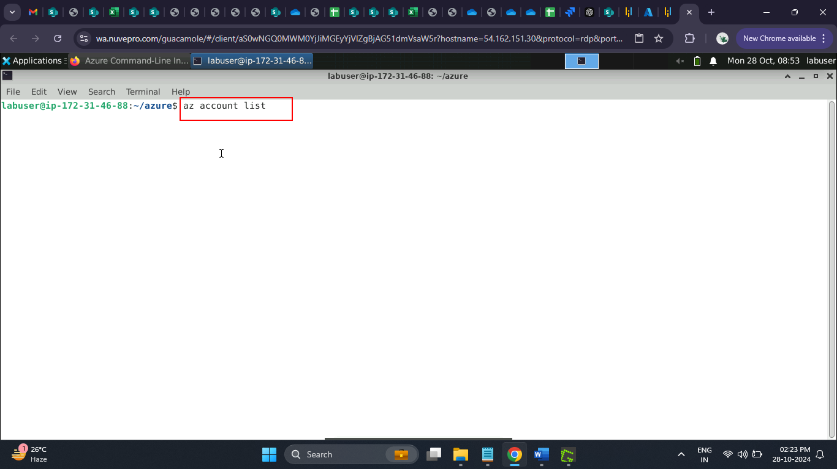

The Azure account list is displayed successfully.

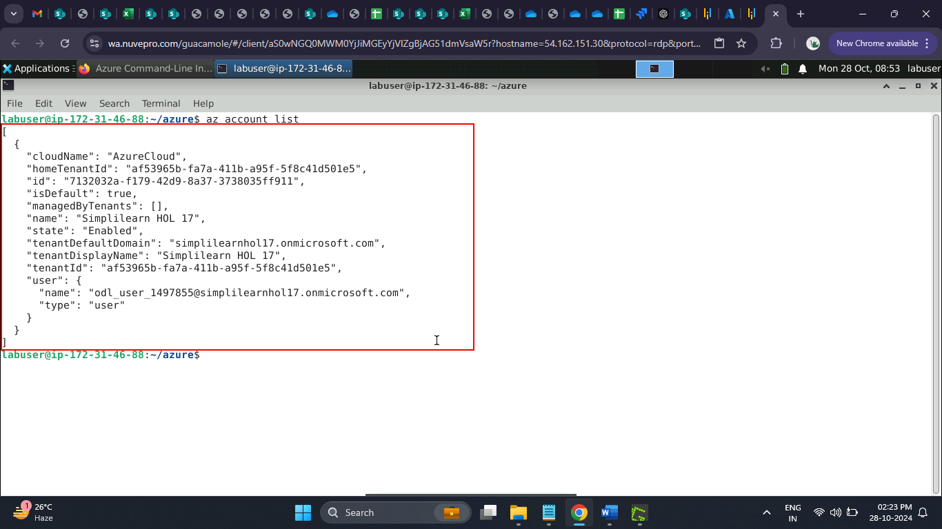

**Step 2: Configure Azure Web app for Containers with high availability configuration**

* 1. Navigate back to the terminal and run the command below to initialize Terraform

**terraform init**

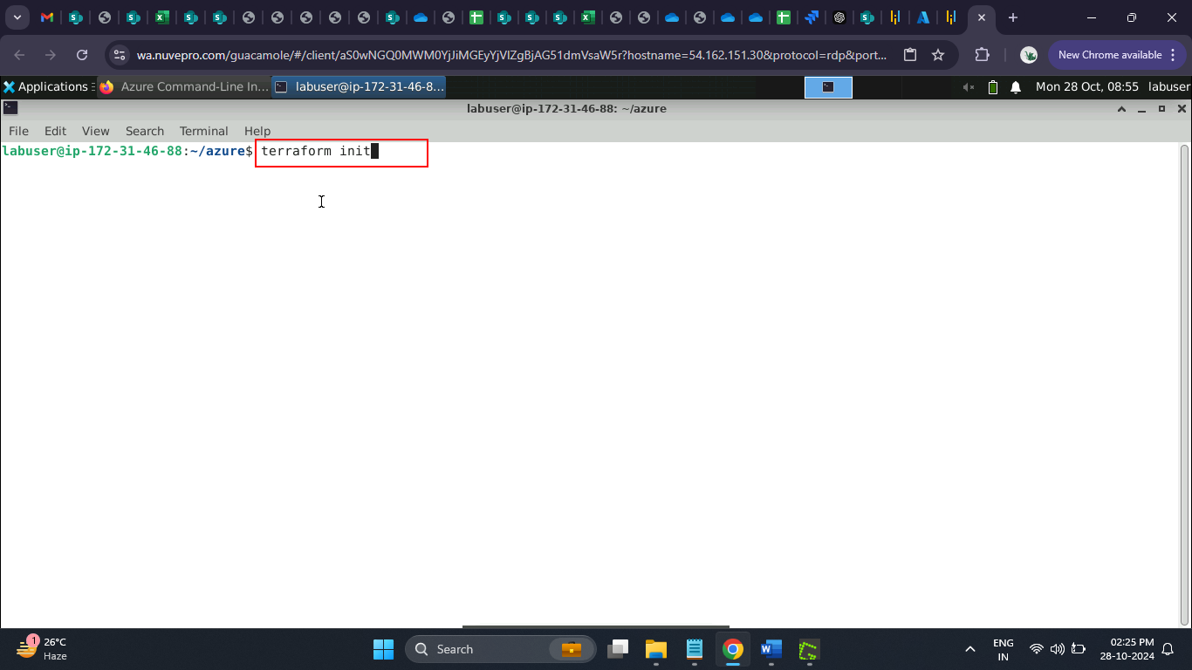

The terraform is successfully initialized.

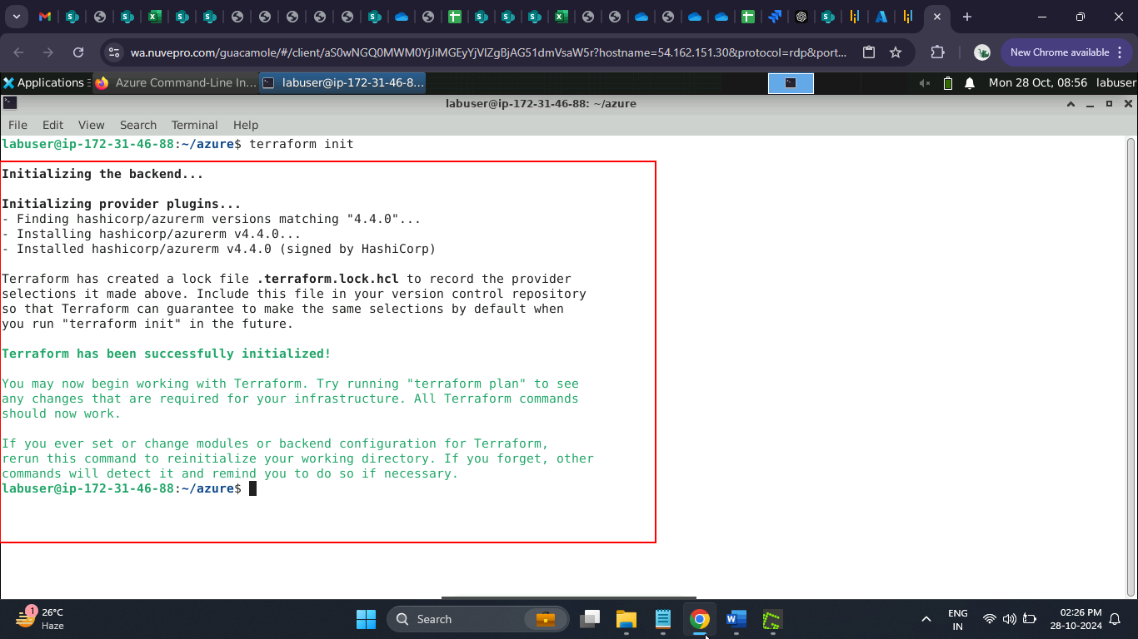

* 1. Execute the command below to apply the Terraform initialization

**terraform apply**

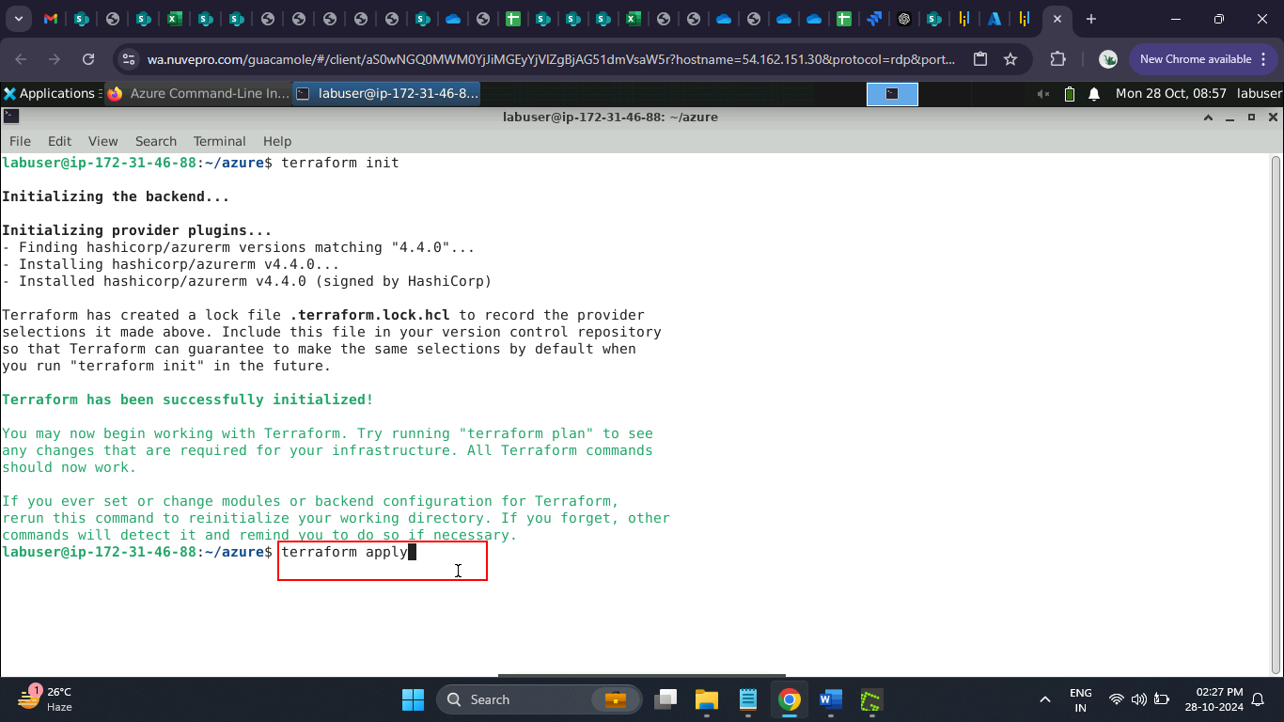

* 1. Enter **yes** to run the apply

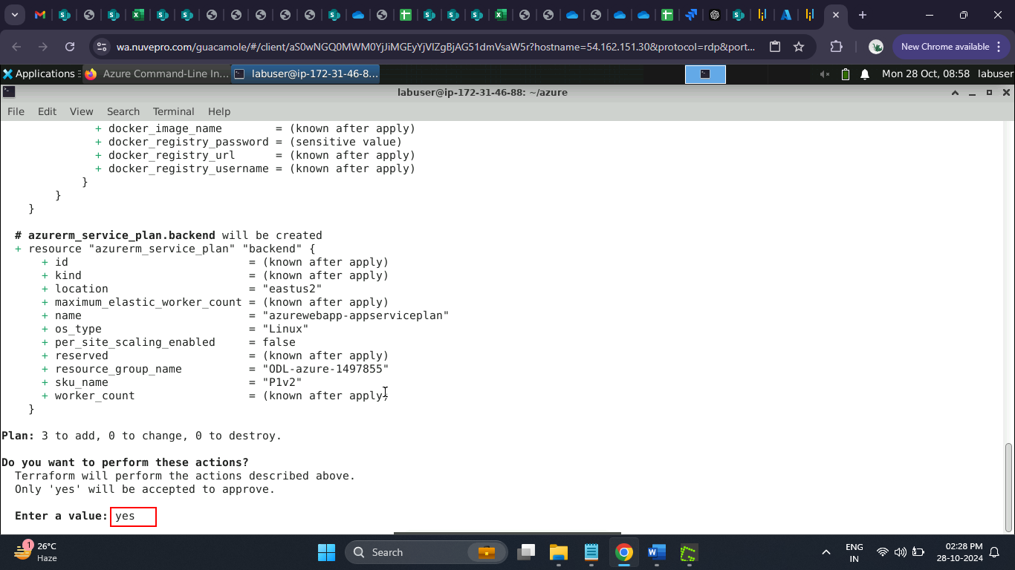

The Terraform apply ran successfully.

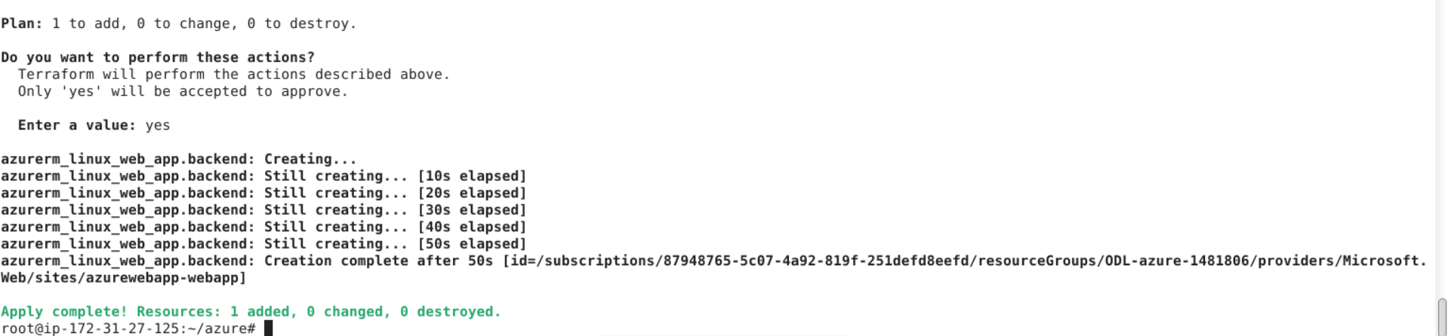

* 1. Navigate back to the Azure portal logged in during step 1.18 to validate the newly created application

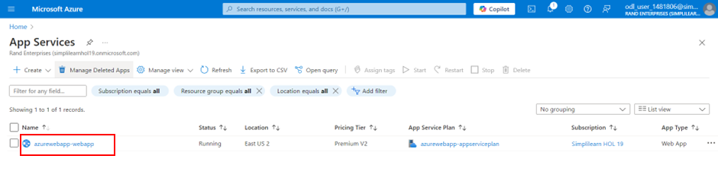

**Note:** If an

**Step 3: Configure Jenkins to automate CI CD workflow**

1. Open the browser in the lab and enter the URL below

**http://localhost:8080/**

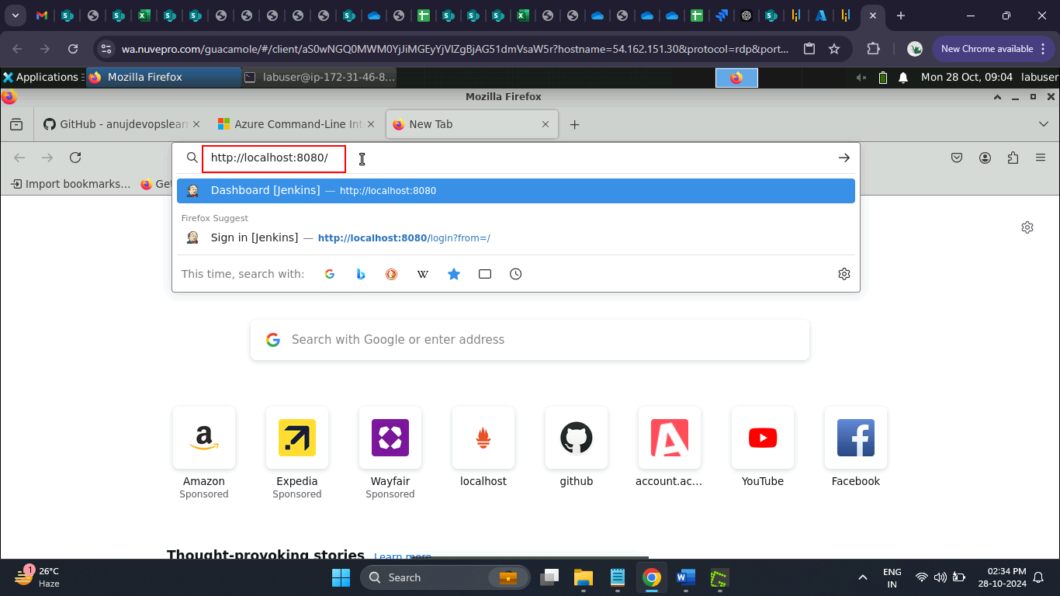

1. Enter the **Username** and **Password**, and click the **Sign in** button

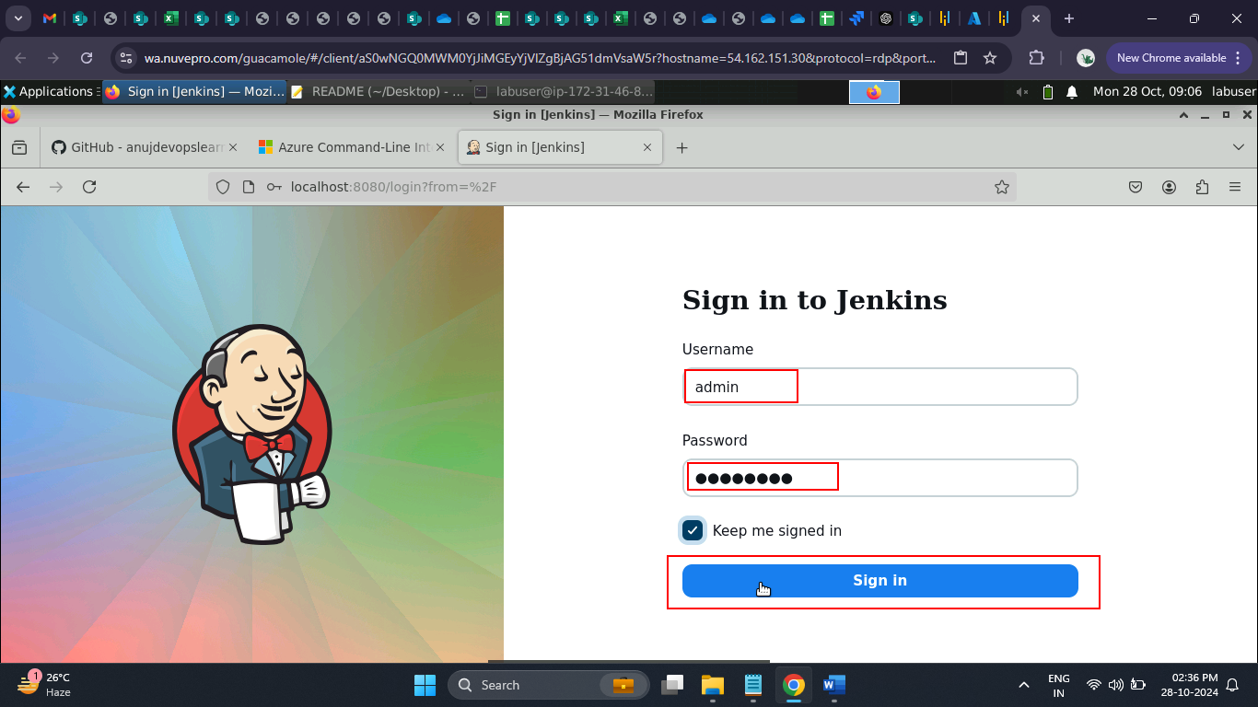

Use the below credentials for the login:

Username: admin

Password: Root123$

The Jenkins dashboard opens up as shown below.

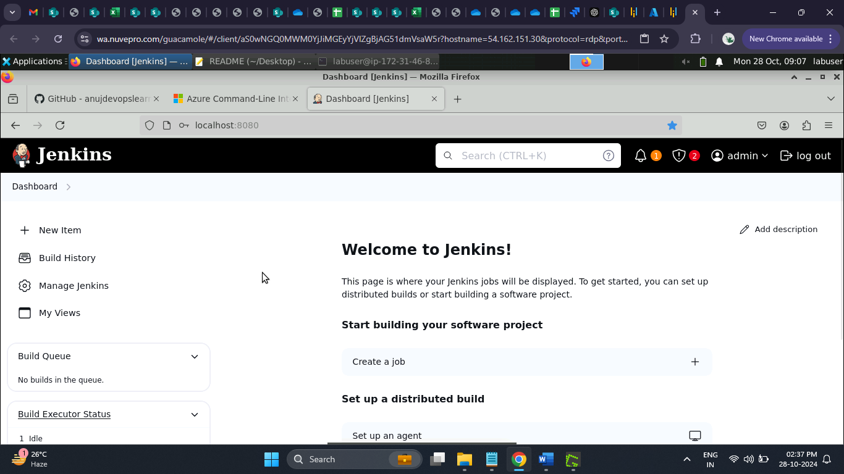

1. Naviagte back to the terminal and run the below command to validate if docker runtime is installed:

**docker version**

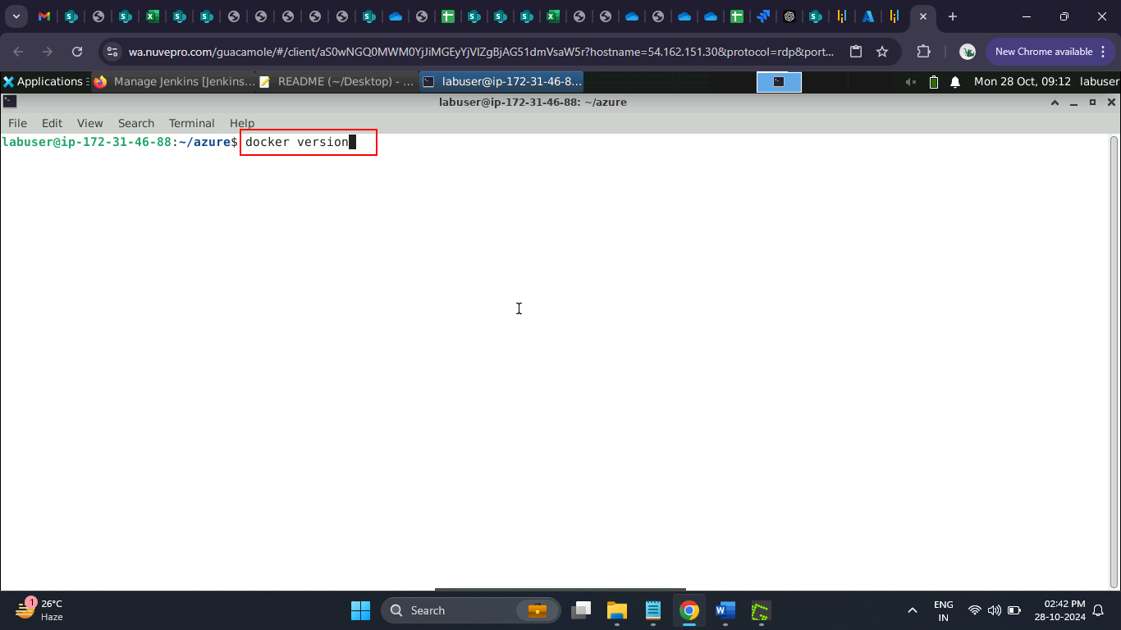

The docker is installed properly, as shown below.

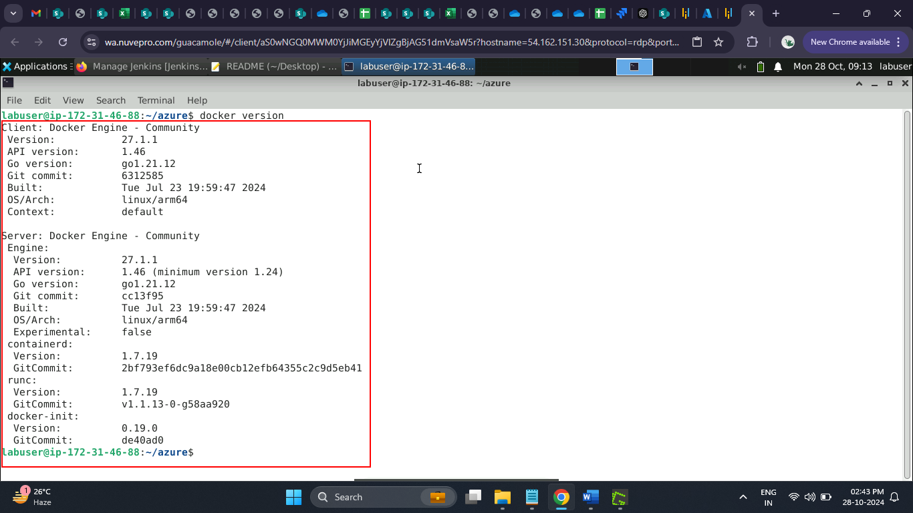

1. Fork the GitHub repository below and validate that Maven scripts are present in the code repository to execute the Jenkins pipeline:

**https://github.com/GithubWorkstation/SpringBootApplication**

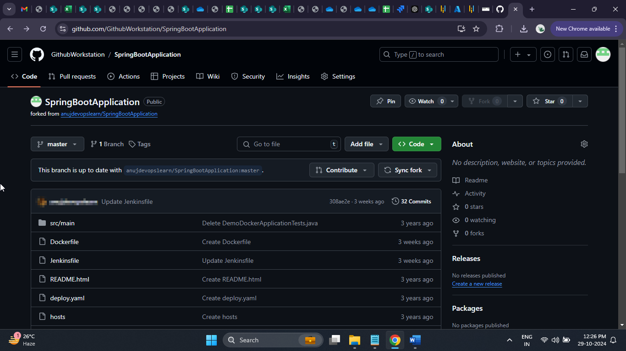

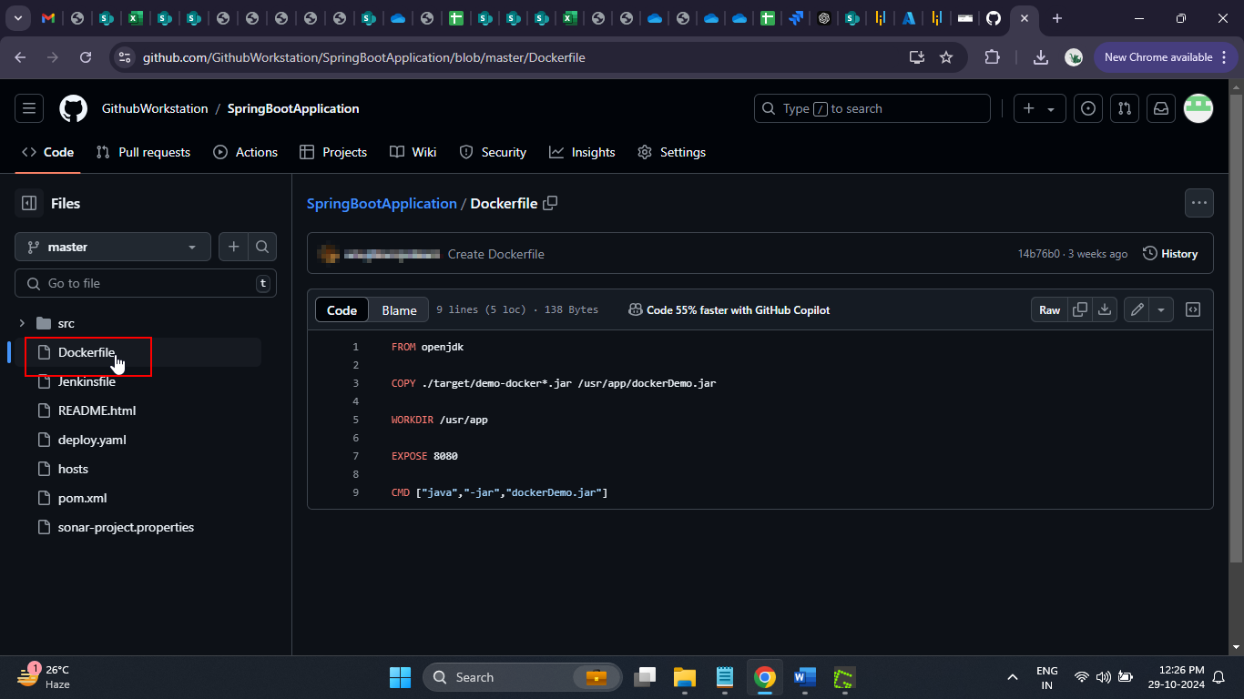

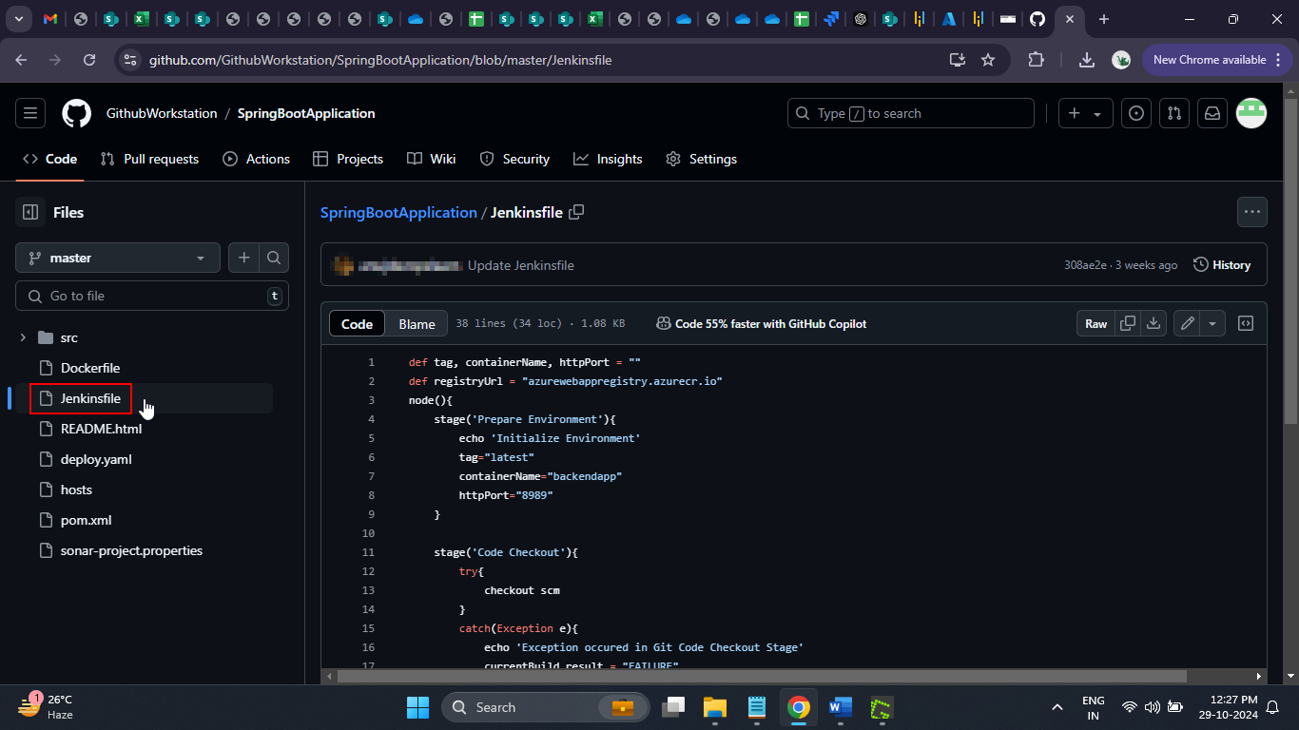

1. Navigate to the Jenkins dashboard and click on **+ New Item**

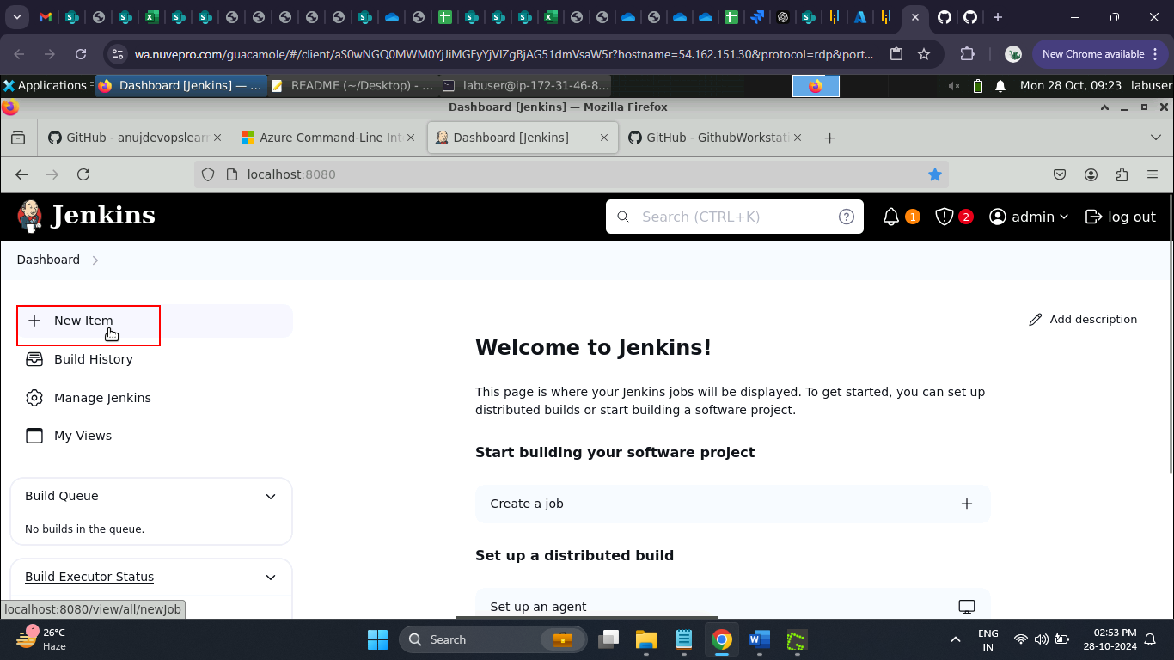

1. Enter the job name as **CICDPipeline**, select the job type as **Pipeline**, and click **OK**

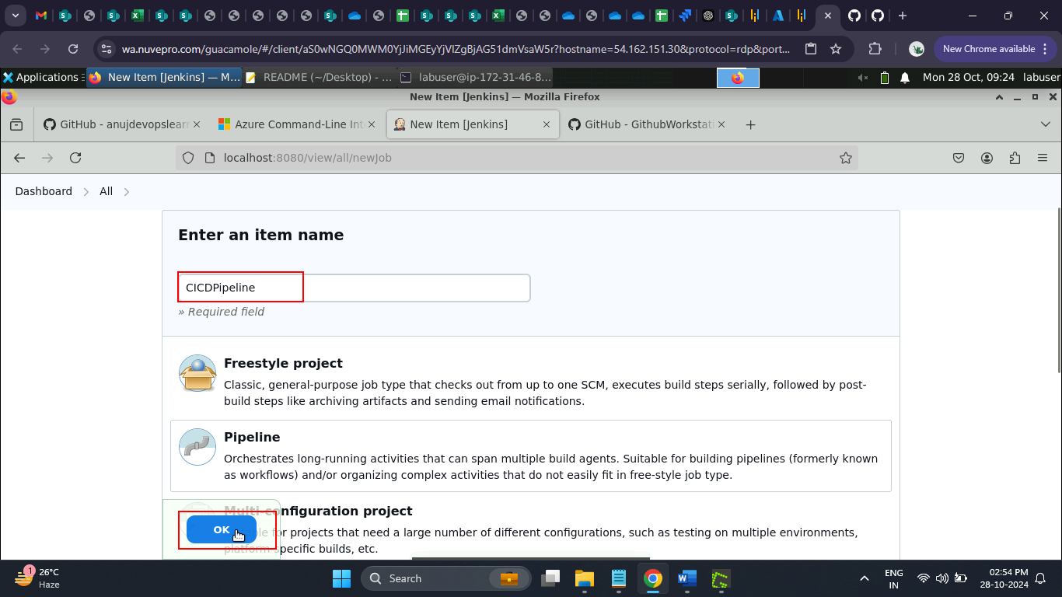

1. Provide Jenkins job details, such as parameters and pipeline configuration, on the Jenkins job configuration page

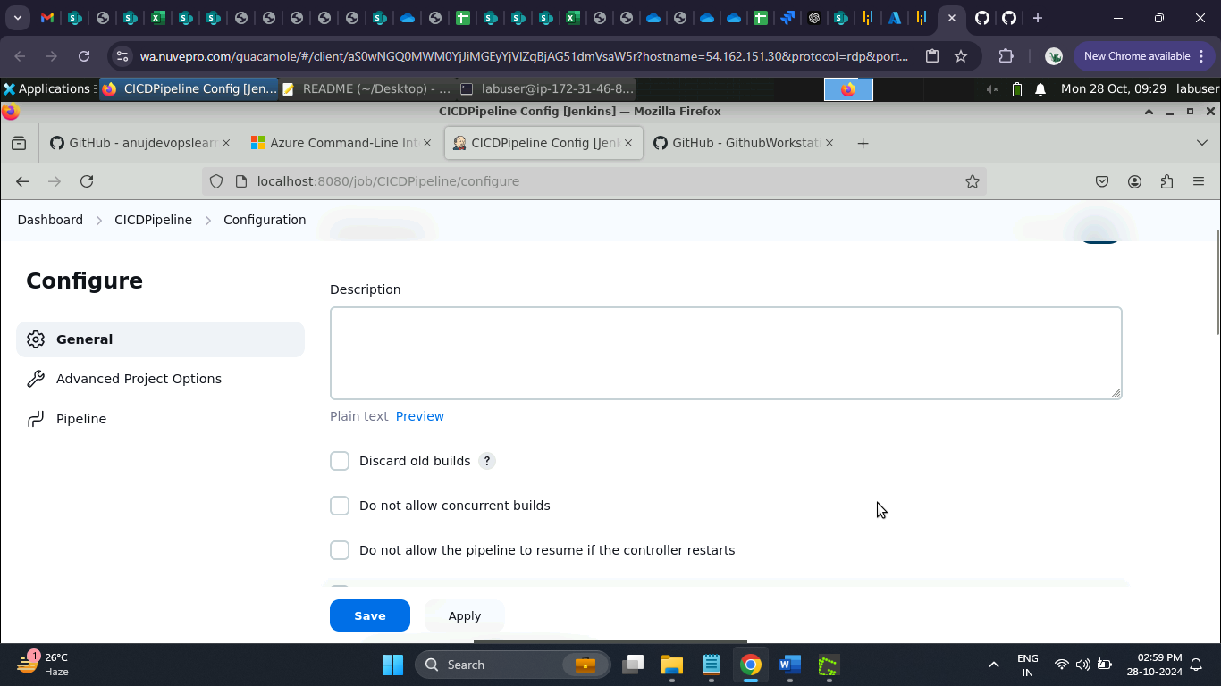

1. Enter the **Definition**, **Pipeline script**, and **Script Path**

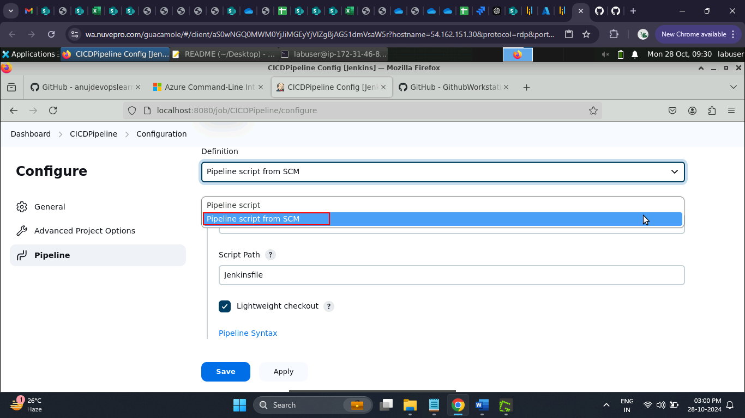

1. Under **SCM** choose **Git**

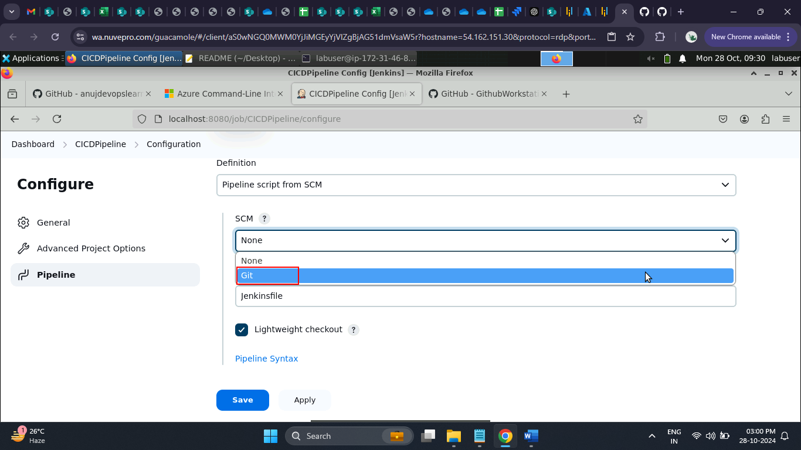

1. Enter the **Repository URL** as given below and select the **Credentials** as **Jenkins**:

**https://github.com/GithubWorkstation/SpringBootApplication**

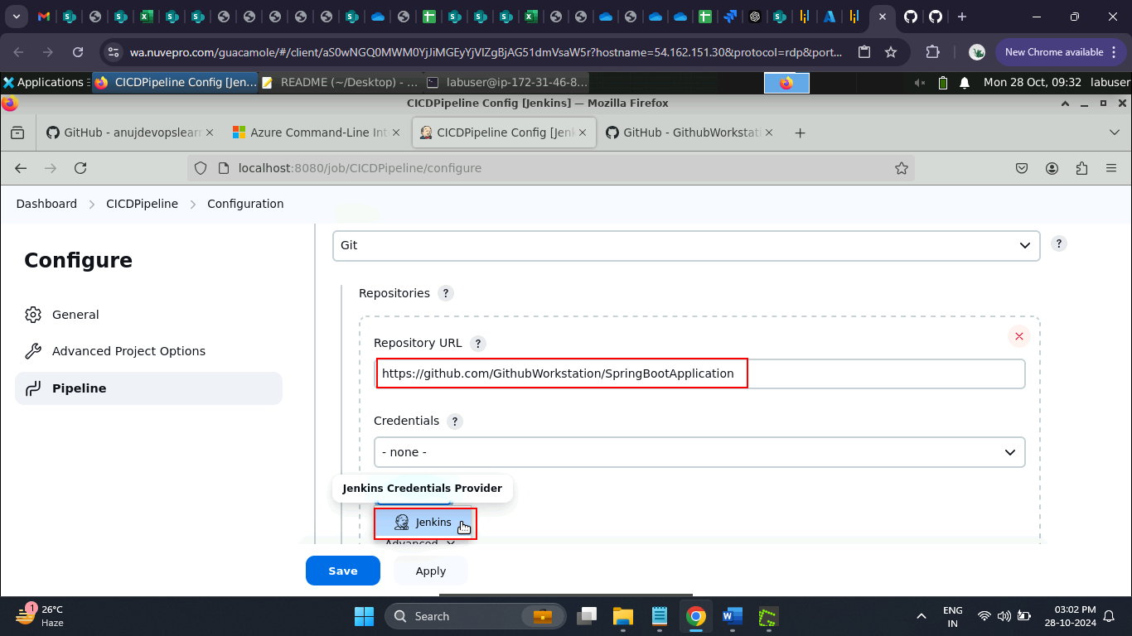

1. Enter the **Script Path** as **Jenkinsfile** and click the **Save** button

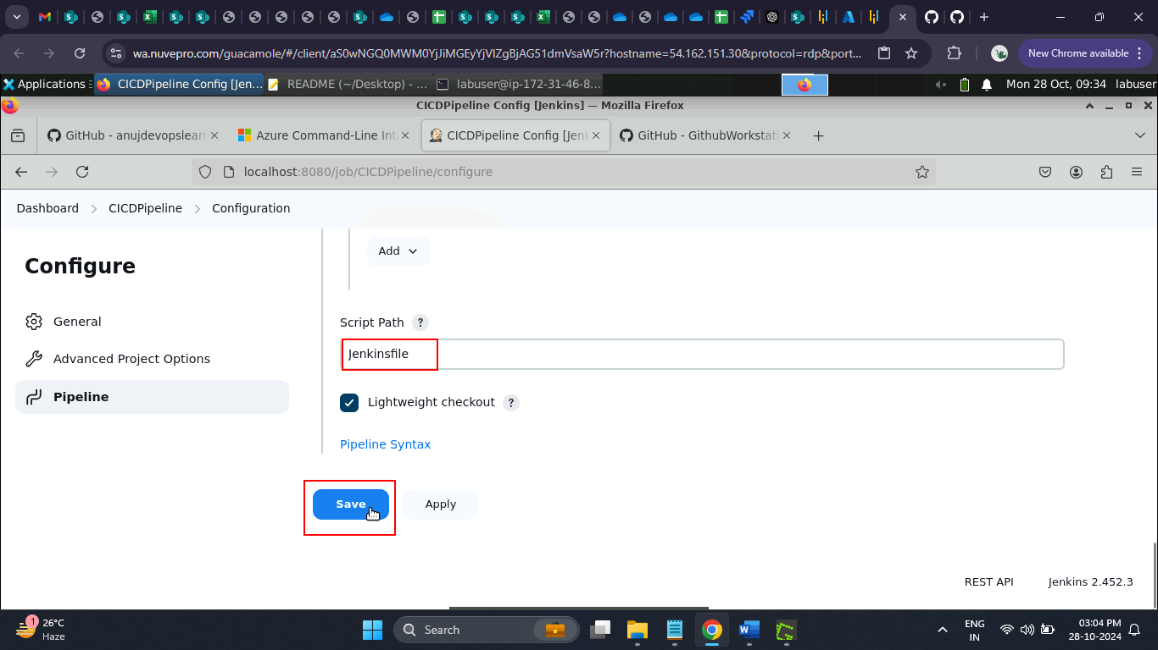

1. Verify that the code checkout stage is included in the pipeline script

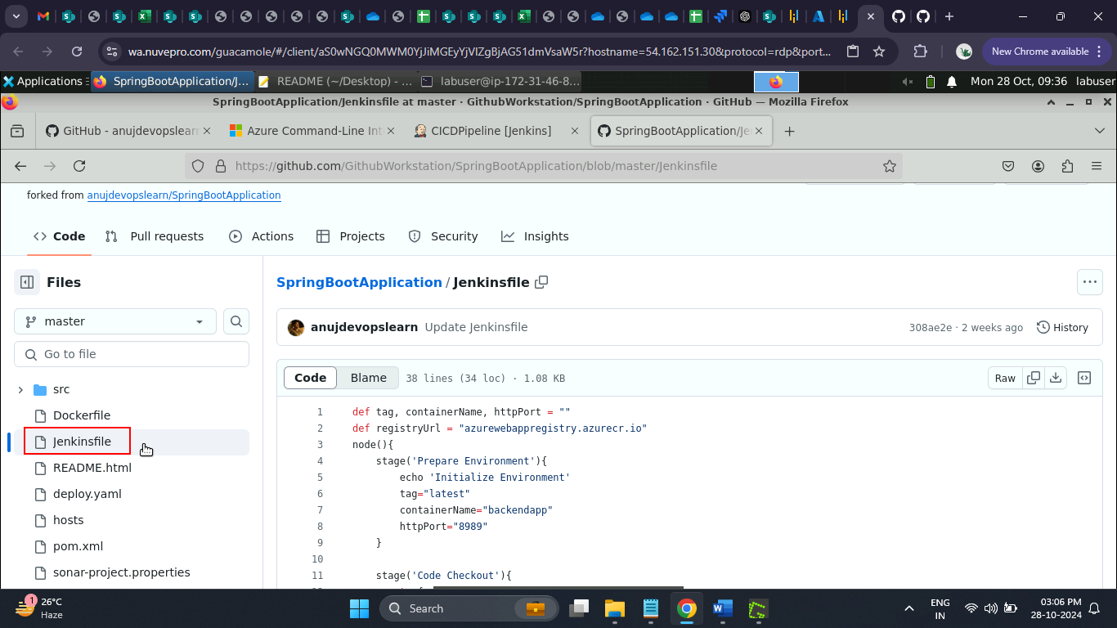

1. Navigate to Azure Container Registry and select the desired registry

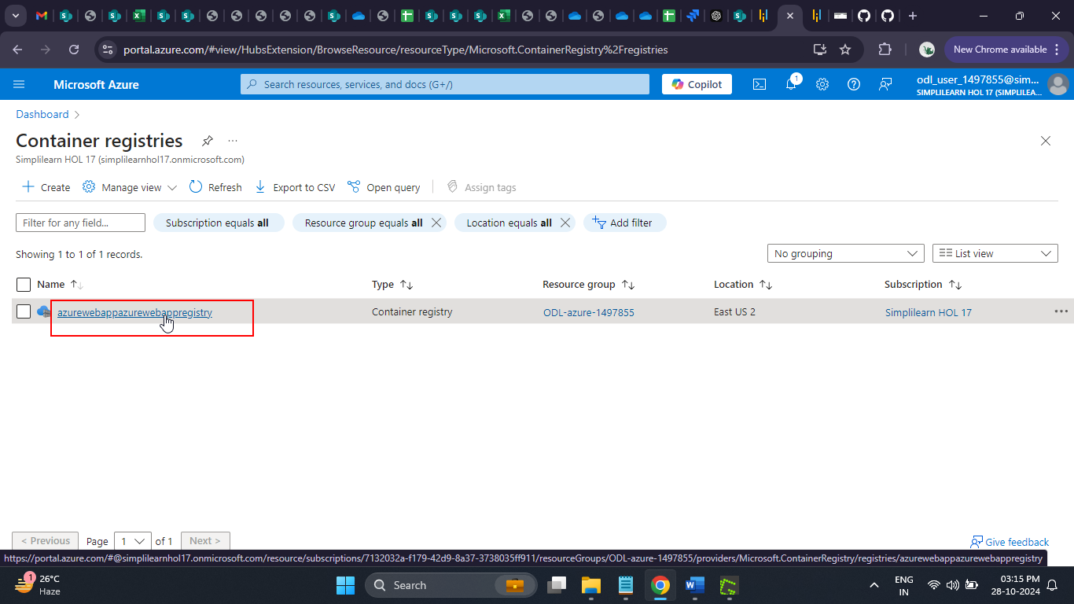

1. Click on Access keys to retrieve the username and password, which will be used to configure Jenkins credentials

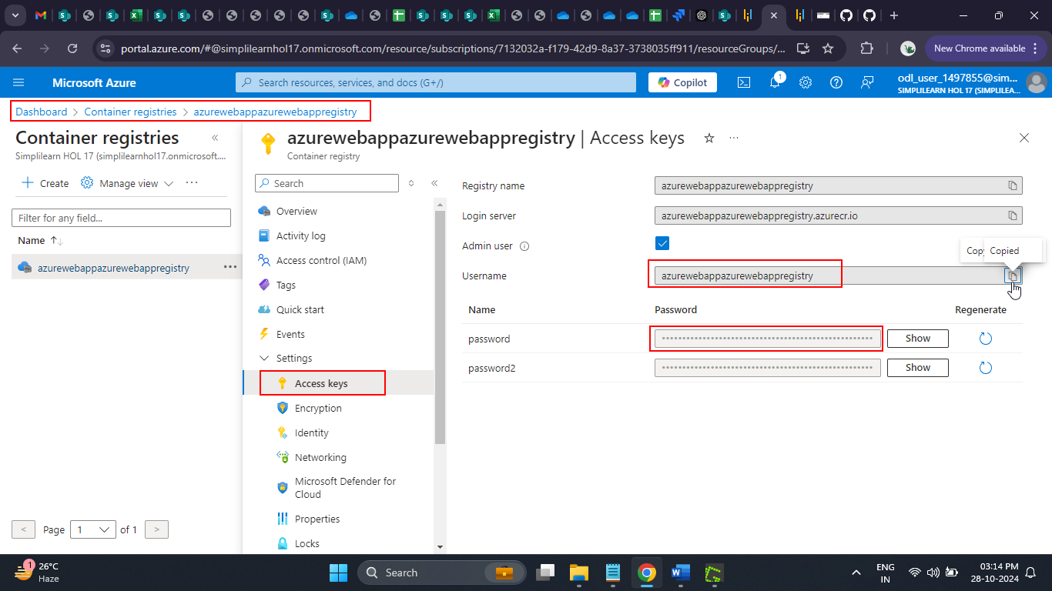

1. Navigate to the Jenkins dashboard and click on **Manage Jenkins**

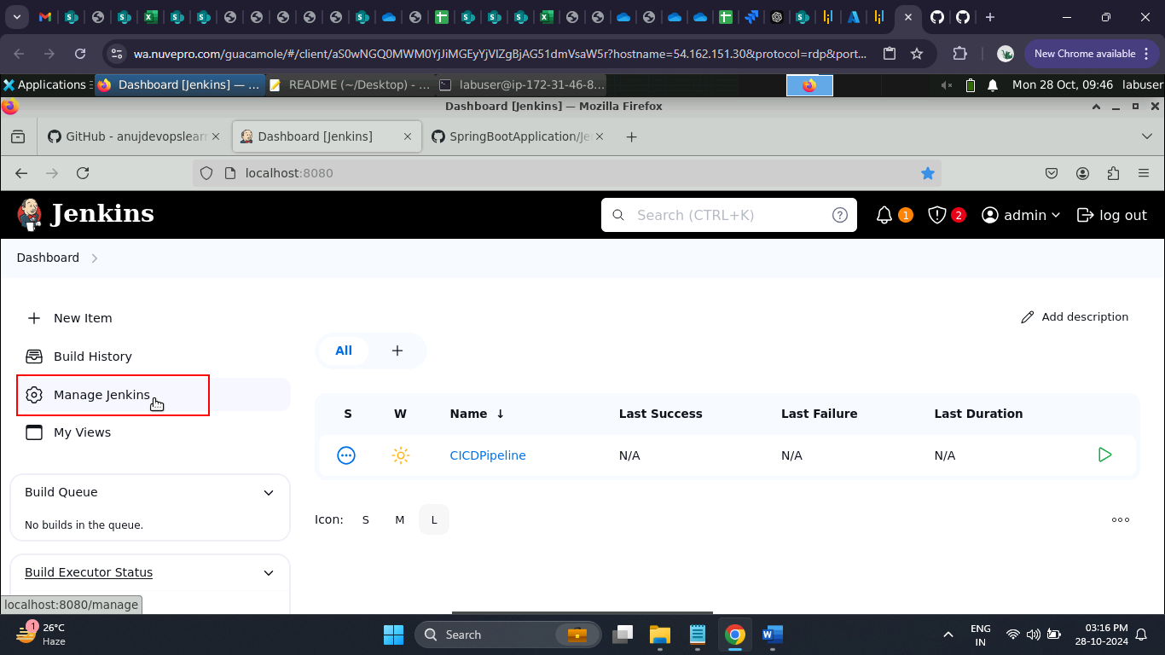

1. Click on **Credentials**

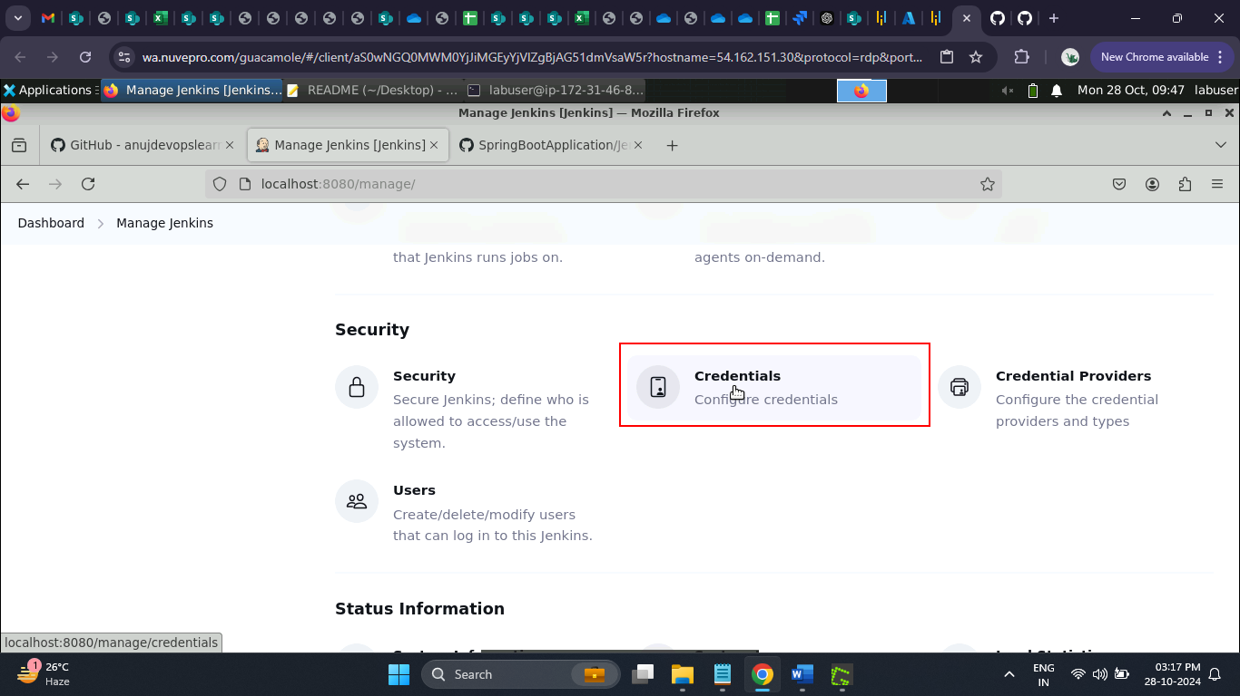

1. Select the **Global** domain

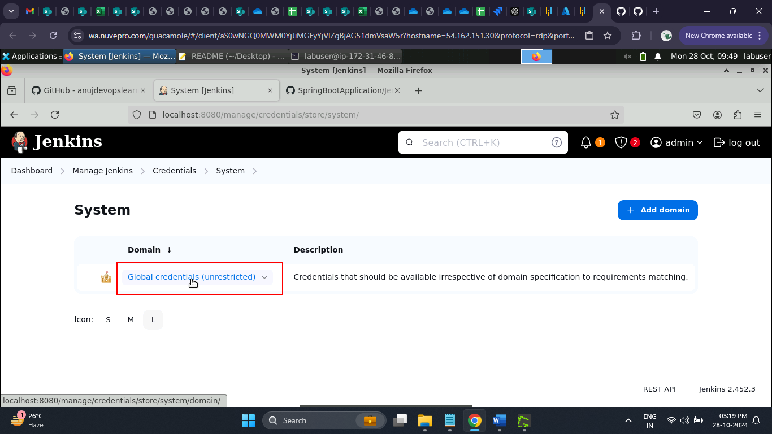

1. Click on **Add Credentials**

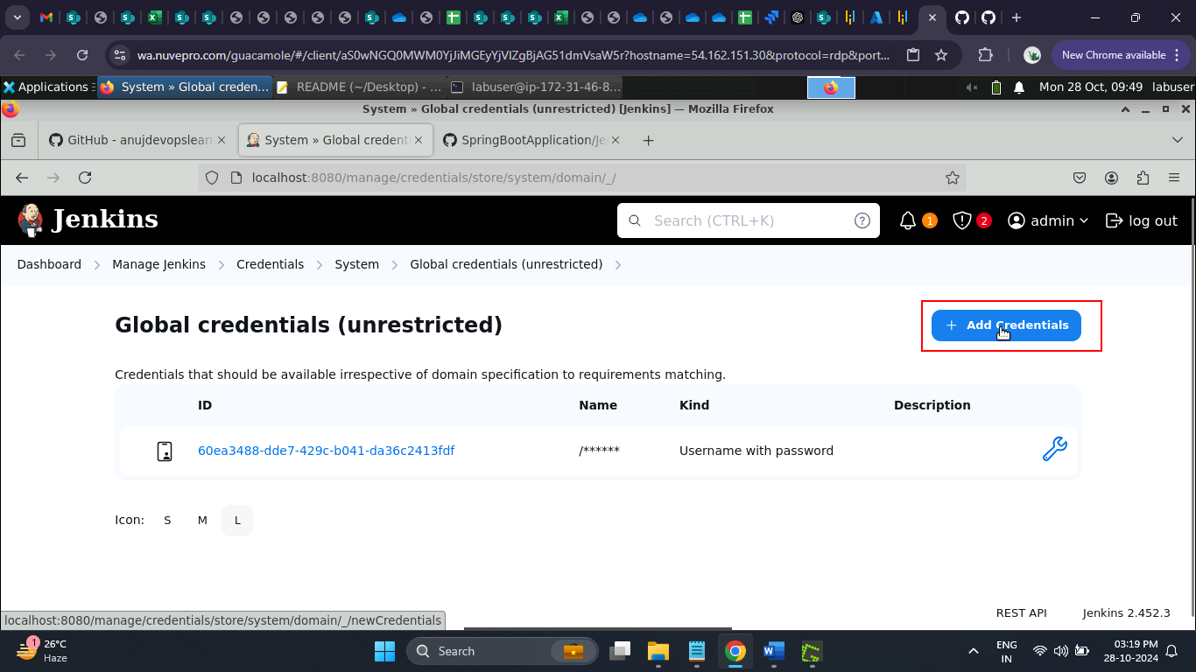

1. Enter the **Username** retrieved in step 3.14

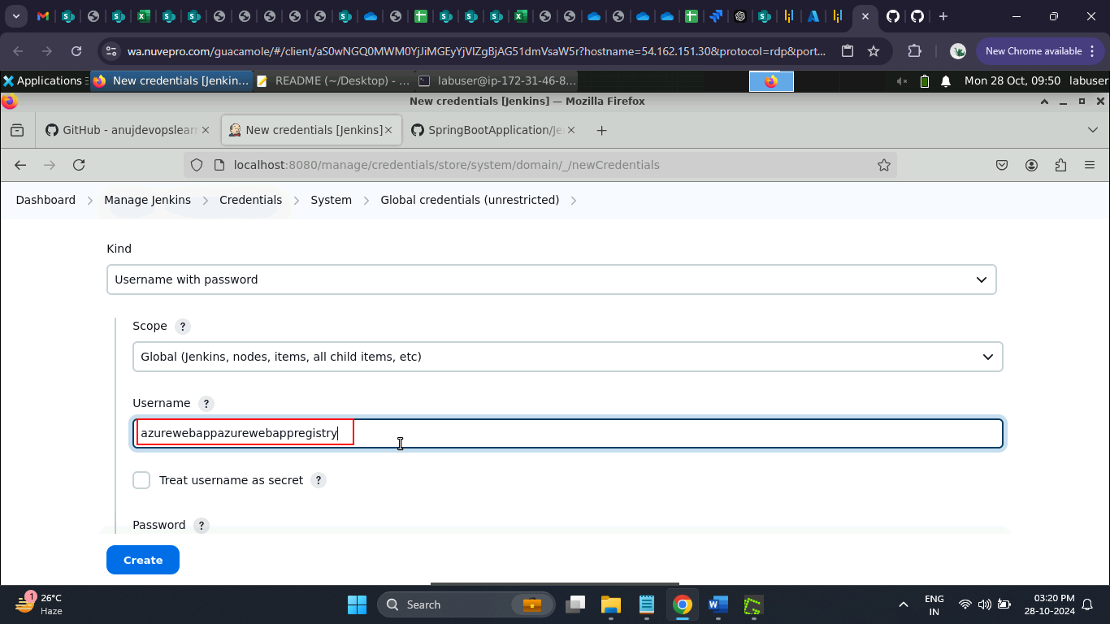

1. Enter the **ID** as **dockerACRaccount** and the **Description** as **ACR Credentials**, then click the **Create** button

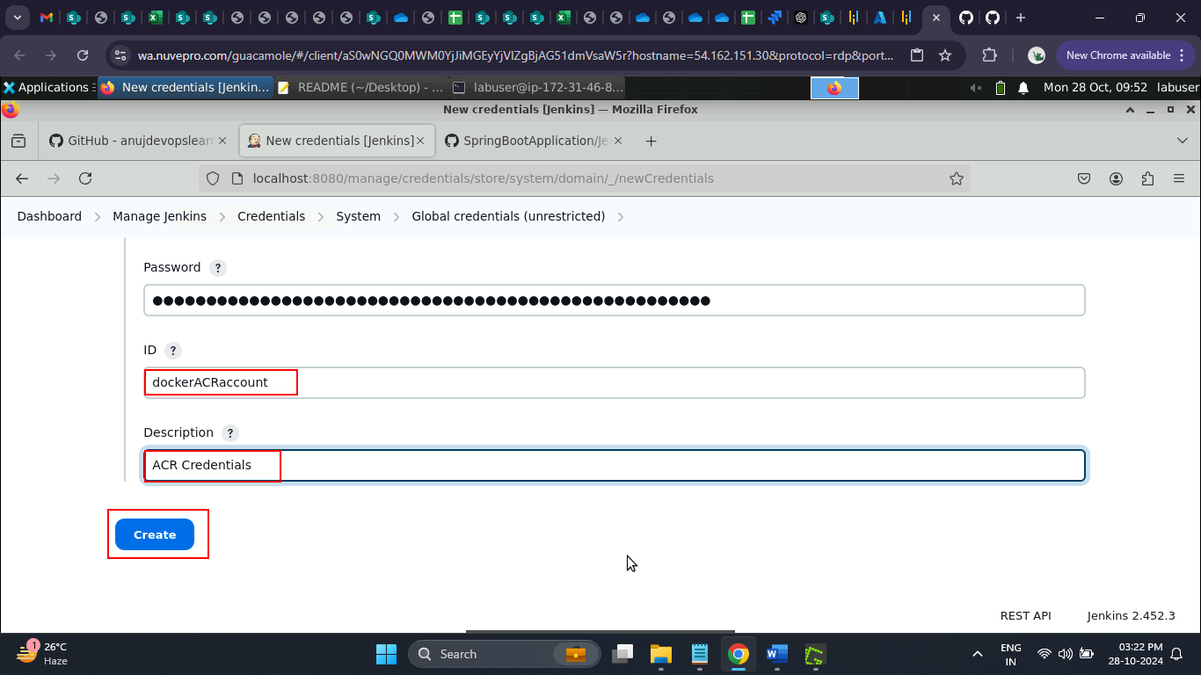

The credentials are updated successfully.

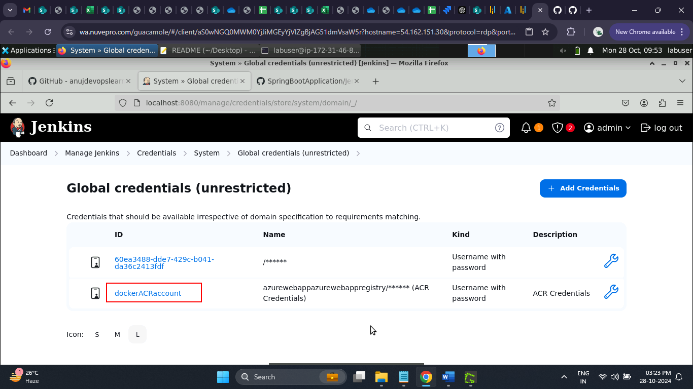

1. Navigate back to the terminal and run the command below to grant full access to the Docker sock file

**sudo chmod 777 /var/run/docker.sock**

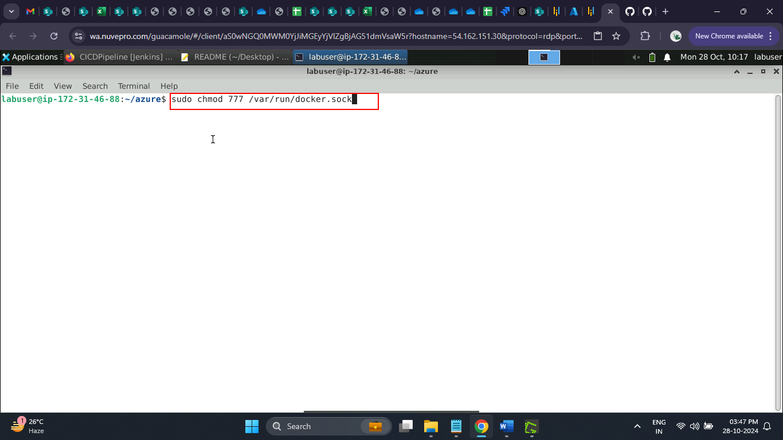

The access command ran successfully, as shown below.

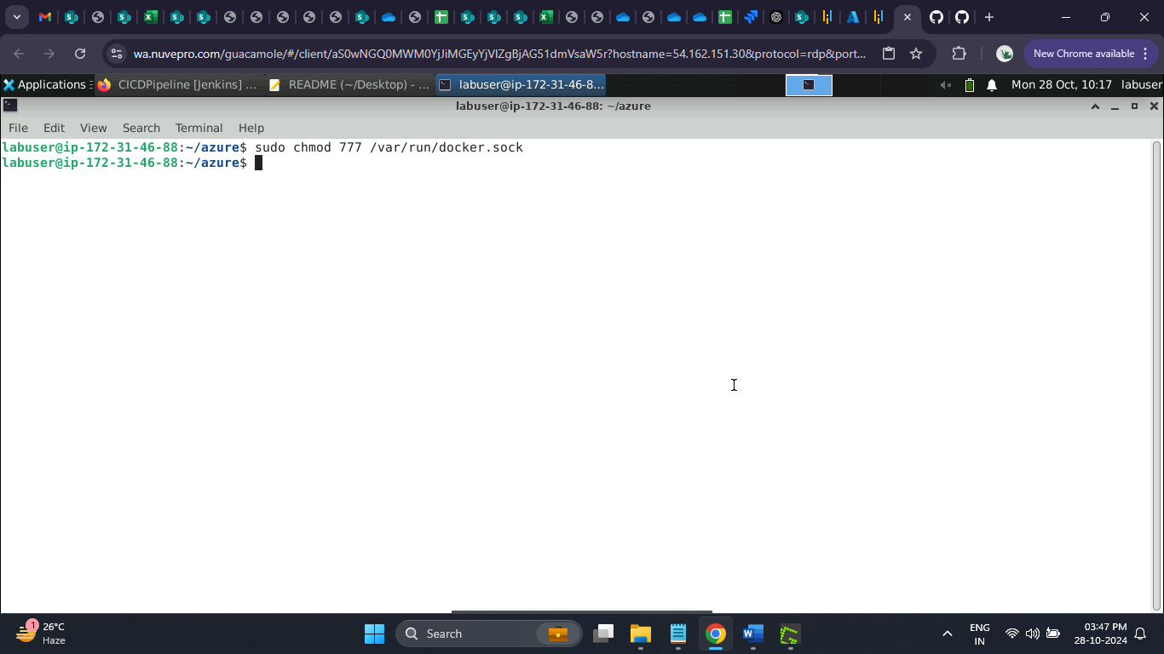

1. Navigate to Jenkins and click on **Build Now**

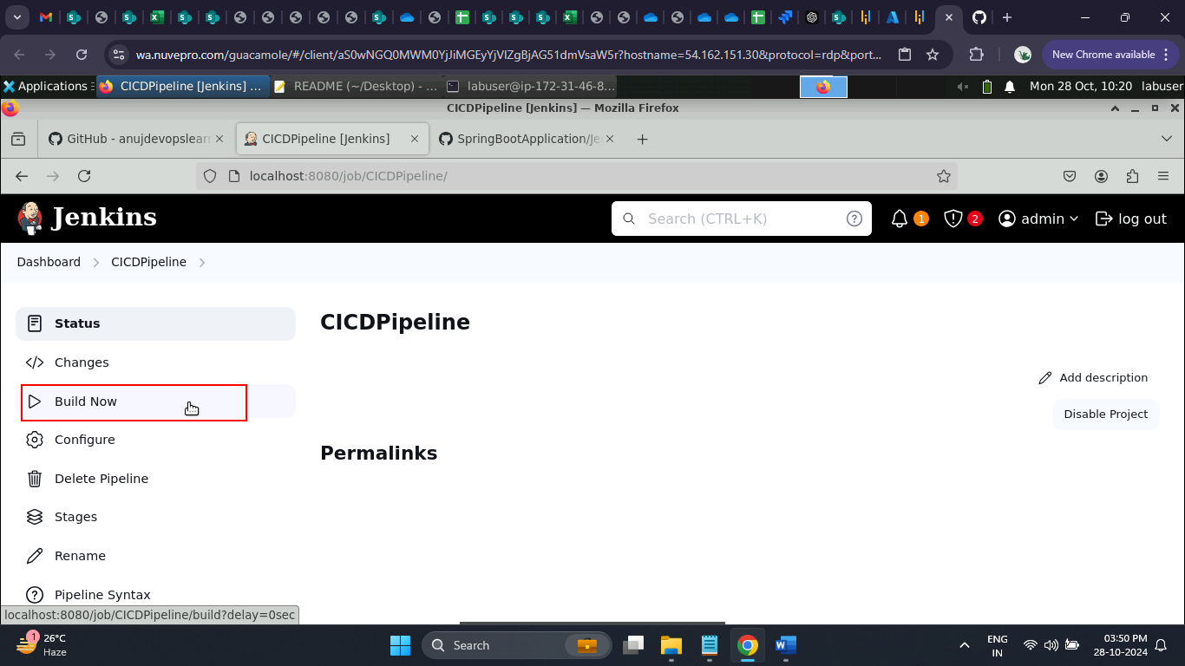

The pipeline starts building, as shown below.

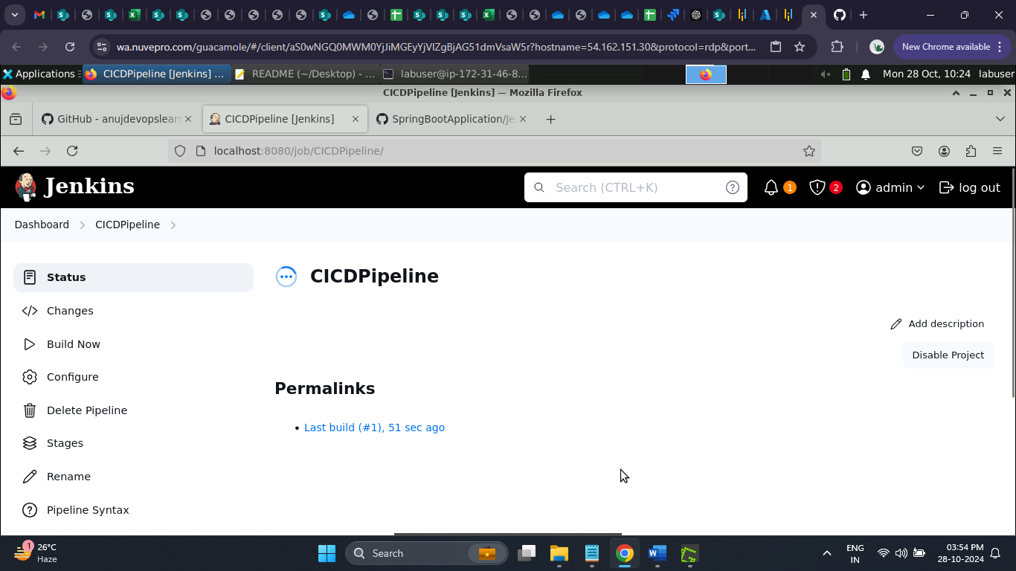

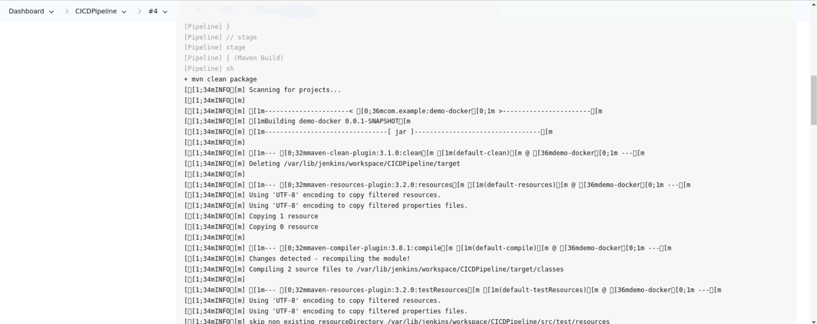

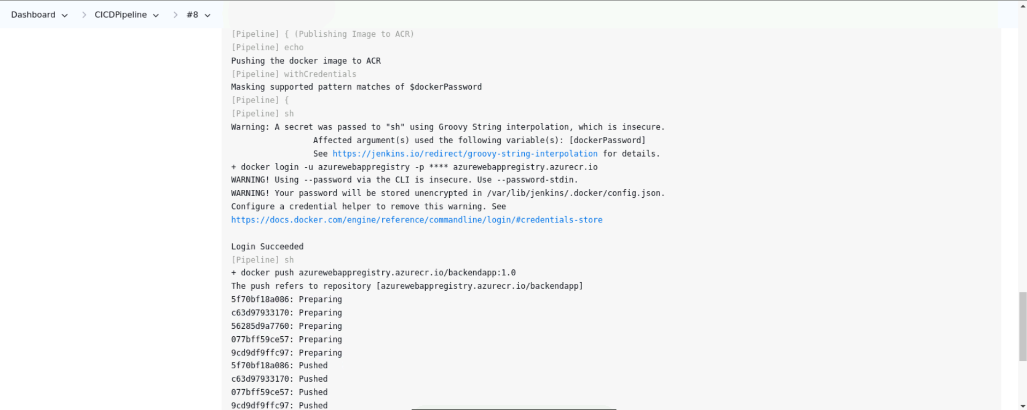

1. Navigate to ACR and select the registry published by the Jenkins pipeline

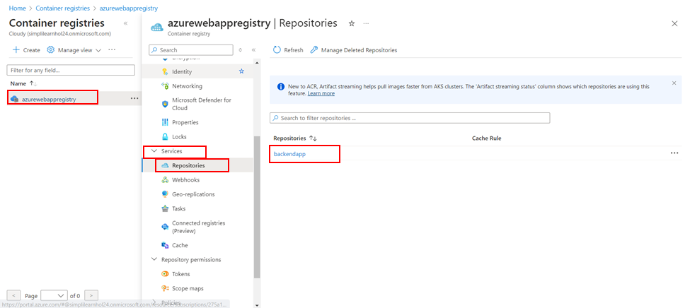

1. Configure the Azure Web App with the latest Docker image tag, as shown in the screenshot below:

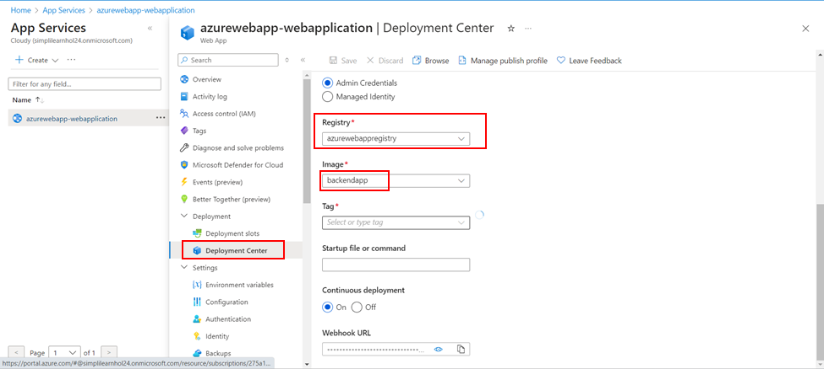

1. Once the configurations are selected, click Save, which will force the Azure Web App to restart, automatically picking up the latest Docker image and deploying it on the Azure Web App

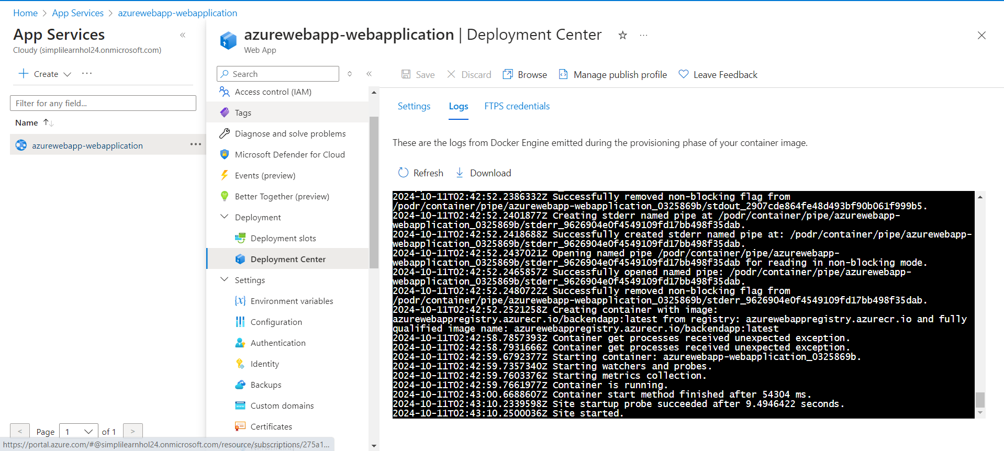

1. Copy the Application URL to access the Backend Application

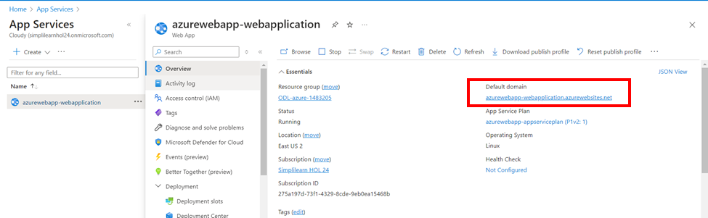

1. Open the URL in the browser

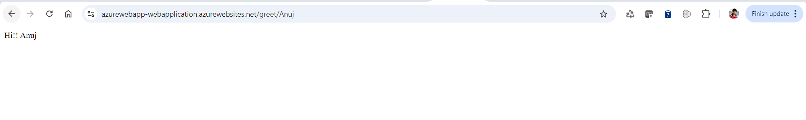

By following these steps, you have successfully automated the provisioned infrastructure, enabling the creation of a new Azure Web App and the automation of CI/CD workflows to deploy microservices applications.